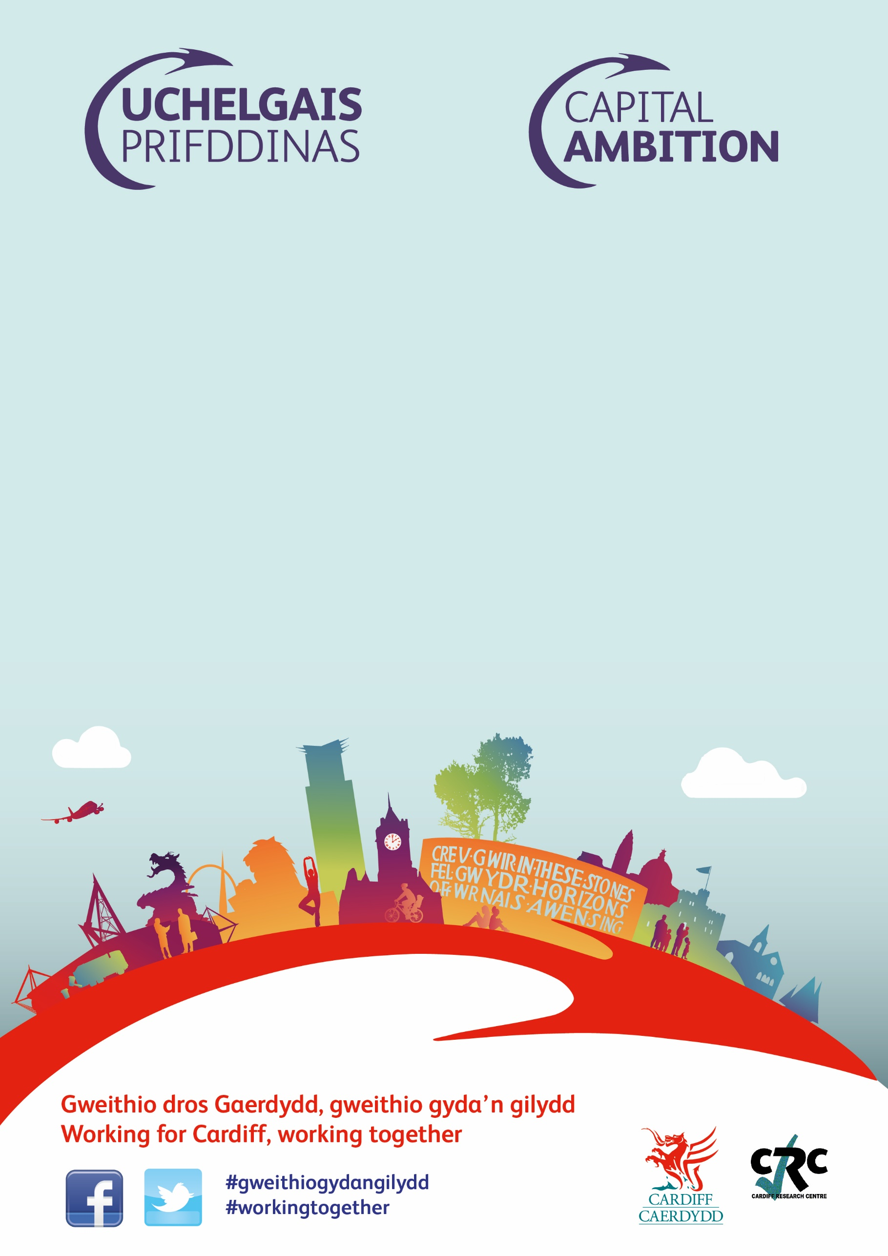
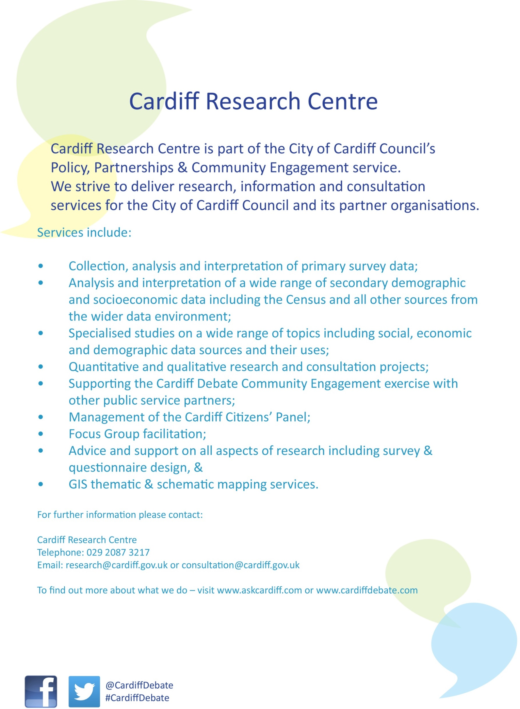

Replacement Local Development Plan Public Consultation

Report
August 2021

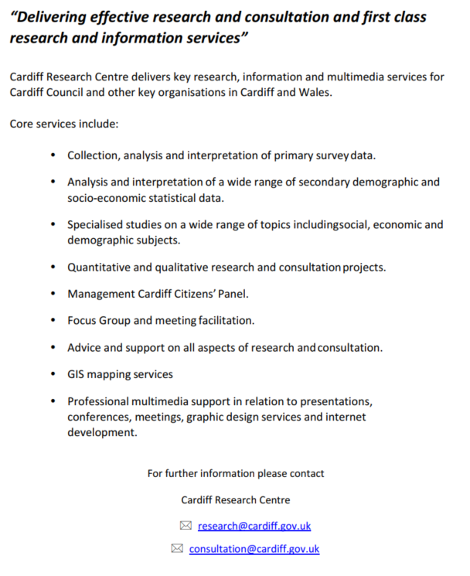

Local Development Plan Consultation Results
Contents
Background 1
Methodology 1
Topic 1: New Houses and Homes 2
Issue: Where development should happen 2
Issue: Homes of the future 7
Topic 2: New Jobs 9
Issue: A growing city - jobs 9
Issue: Workplaces of the future 12
Topic 3: New Infrastructure to support growth 14
Issue: Priorities for new infrastructure 14
Topic 4: Tackling the Climate Emergency 16
Issue: How to tackle the climate emergency 16
Topic 5: Moving around the city 18
Issue: Modal split target 18
Issue: Delivering Sustainable Transport Infrastructure 20
Topic 6: Heathier Environments 22
Issue: Improving health and well-being 22
Topic 7: Supporting the roles of the City Centre and Cardiff Bay 25
Issue: Future role of city centre 25
Topic 8: Post Pandemic Recovery 29
Issue: Helping the city recover from the pandemic 29
Topic 9: Creating places where people want to live, work or explore 31
Issue: Creating good places 31
Topic 10: Protecting Green and Blue Infrastructure 38
Issue: Green Spaces 38
Issue: Nature and Trees 41
Topic 11: Protecting historic and cultural assets 43
Issue: Historic and cultural assets 43
12: Vision and Objectives 44
13. Additional Comments 50

Appendix 1 – Demographic Profile of Respondents 51
Appendix 2 – Breakdown of Results for Priorities for new infrastructure by Demographic Groups 56
Appendix 3 – A home that is... “Something else” 61
Appendix 4 - What kind of balance should the plan strike in addressing future jobs growth? Please explain your answer 64
Appendix 6 - Workplaces of the Future by Demographic Groups 69
Appendix 7 - Priorities for new infrastructure: Please list any other facilities 71
Appendix 8 - Breakdown of Results for Priorities for new infrastructure by Demographic Groups 74
Appendix 9 – How do you think the plan can tackle climate change? 76
Appendix 10 – Breakdown of Results for Delivering Sustainable Transport Infrastructure by Demographic Groups 80
Appendix 11 – Please specify where else infrastructure resources should be invested 83
Appendix 11 – Breakdown of Results for Improving health and well-being by Demographic Groups 85
Appendix 12 – Breakdown of Results for “What do you think the future role of the city centre should be?” by Demographic Groups 88
Appendix 13 – Breakdown of Results for “In the future, how often would you be likely to use the following in the city centre for each of the following?” by Demographic Groups 90
Appendix 14 – Improving Health and Well-being: Please specify what else you consider to be important 93
Appendix 15 – What do you think the future role of the city centre should be?: Something else 95
Appendix 16 – Breakdown of Results for “In the future, how often would you be likely to use the following in the city centre for each of the following?” by Demographic Groups 96
Appendix 17 – For what other purpose would you use the city centre? 101
Appendix 18 – Post-Pandemic Recovery: Breakdown by demographic groups 102
Appendix 19 – Post-Pandemic Recovery: Please specify what else you consider to be important 105
Appendix 20 – Breakdown of Results for “What do you think is good about your neighbourhood?” by Demographic Groups 106
Appendix 21 - What do you think is good about your neighbourhood?: Something else 111
Appendix 22 – Breakdown of Results for “What do you think could be done to improve your local neighbourhood?” by Demographic Groups 112
Appendix 23 - What do you think could be done to improve your local neighbourhood?: Something else 117
Appendix 24 – Green Spaces: What Other Approaches Would You Suggest? 119
Appendix 25 – What measures do you think the plan needs to put in place to protect the city’s historic assets and further enhance and promote the city’s role as a capital city and as an international destination for residents and visitors? 122
Appendix 26 – Let Us Know How You Think the Vision Could Be Improved 125
Appendix 27 – Breakdown of Results for “Please rank the draft plan objectives in order of importance” by Demographic Groups 128
Appendix 28 – Would You Add Any Other Objectives? 136
Appendix 29 – Do You Have Any Other Comments? 138

Background
The Replacement Local Development Plan (LDP) will help shape Cardiff for the next 15 years to 2036 ensuring the right development happens in the right place at the right time, benefitting communities and the economy and setting out which areas need to be protected.
The Council is right at the beginning of the process of preparing a new LDP and is keen to get the views of members of the public on the draft Vision, Issues and Objectives for the plan, and some of the big issues that the plan will need to consider, like housing growth, the future of work and travel and how Cardiff tackles the climate emergency.
A consultation was developed to gather feedback on the plan, and ask people to think about the balances the plan will have to consider. Given the COVID-19 restrictions in place at the time of the consultation, which restricted the number of people able to meet, particularly indoors, and forced the closure of public buildings such as Hubs and libraries, the consultation took place as an online survey.

Methodology
The Cardiff Research Centre worked closely with partnership organisations to ensure as representative a response as possible. In a bid to ensure the survey was promoted as widely as possible, the survey was promoted via:
a) Email
• Organisations known to work with less frequently heard groups
• Cardiff’s Citizen’s Panel
b) Internet/intranet
The survey was hosted on the Council website, with promotions on the home page and the Have Your Say section. A dedicated “Virtual Consultation Room” was set up on www.cardiffldp.co.uk, providing members of the public with the background to the plan and links to the consultation.
c) Social media
The survey was promoted via Facebook and Twitter throughout the consultation period. Social media ‘boosts’ were made to selected demographics with a traditionally lo response rate.

Once the consultation closed, the responses were cleansed and validated, to remove blank or duplicate responses. A total of 1,215 responses were received for the survey overall, with respondents able to skip questions they did not wish to answer. The response rate for each question is included in the report.

Topic 1: New Houses and Homes

Issue: Where development should happen
Cardiff is a fast-growing city – 8,000 homes have been built over the last 10 years.

A growing city requires space for new housing.

Low housing supply can lead to ever-increasing house prices leaving more people struggling to afford a secure place to live. Growth therefore provides opportunities for providing a range and choice of homes and for more affordable housing.

However, it can also lead to pressures such as the need to release of greenfield land and provide supporting infrastructure such as transport facilities, schools and health facilities.

What kind of balance should the plan strike in addressing future growth for more homes?
A total of 1,157 responses were received for this question, giving a response rate of 95.2%
Respondents were asked to indicate the level of housing growth the plan should consider, rating from a score of zero for no housing growth, fifty for the midpoint, and one hundred for high housing growth. The resulting scores were used to calculate an overall score to indicate how much housing growth was preferred – a lower score signifies no growth, while a higher score indicates high housing growth.

Overall, 7.3% of respondents wanted to see no housing growth in the Replacement Local Development Plan, 12.9% wanted mid-level growth, and 7.0% high housing growth. Almost half (46.6%) indicated a lower level of growth (scoring 10 to 40) compared with a quarter (26.2%) who suggested a higher level (scoring 60 to 90). The overall score was 43.5, suggesting a moderate level of housing growth is optimal.

Looking at scores by respondent group showed a broad consistency of opinion, with just 15.6 points between the highest and lowest scores, based on a 100 point scale

Respondents who identified as disabled, and those under the age of 35 wanted higher levels of housing growth, scoring 55.4 and 50.4 respectively.

Women, and those with children in their household indicated the lowest levels of housing growth (39.8 and 41.7 respectively).

Base sizes shown in brackets – caution should be taken with lower base sizes

While there was no clear correlation with level of deprivation, respondents living in the least deprived areas of the city wanted the lowest level of housing growth (35.9).

Base sizes shown in brackets – caution should be taken with lower base sizes
Please explain the reasons for your answer
Respondents were asked to provide reasons for their answer to the above question: 927 comments were received, and grouped into themes. The top three are shown below, with a full breakdown in Appendix 2:
Theme | No | % | Example comments
Houses needed/  Quality /  Affordable housing /  Social housing | 278 | 30.0 | - There is a shortage of affordable housing especially for first time buyers in the city.  - Currently my children will never be able to buy a house  - We need more council housing and low rent costs  - There is a need for affordable housing in Cardiff  - More homes are needed but there is a growing need for cheaper good quality Council and Housing Association homes and not homes which require a mortgage for the privileged people who can afford them.  - More good quality housing is essential.  - Nowhere near enough housing
Preserve Green Space | 273 | 29.4 | - Cardiff is known for being a green city, yet these boundaries are continuously being pushed.  - important to provide housing but still need protect land  - A balance between housing need and the benefits of green spaces  - Green spaces are fundamentally important to the wellbeing of the citizens. Any future building should be on brown field sites  - We need more houses but part of Cardiff’s charm is the proximity to green space.
Need to improve infrastructure/  Services /  Public transport | 235 | 25.4 | - There should be no further land for housing until sufficient infrastructure has been provided to accommodate it.  - traffic is out of control, we need to improve transports and roads before building more houses  - More homes are needed, but the infrastructures always take so much longer to do, and the public transport links are just so poor to the areas now being built on further outside of the City  - The housing supply is currently outstripping the infrastructure and needs to be reduced slightly until an infrastructure plan is delivered

Broadly speaking, there are two ways of allocating land for new housing:

Brownfield: Often around city centres. Includes filling in gaps in existing neighbourhoods and building taller buildings. It can also include old industrial units, although these often come with much higher build-costs.

Green Field: This can typically be on old farmland, using green fields on the edge of urban areas to grow a city. Whilst the development costs are cheaper, so homes can often be more affordable, more infrastructure is needed such as public transport and new schools.

What kind of balance should the plan strike if the city is projected to need new housing?
A total of 1,154 responses were received for this question, giving a response rate of 95.0%
Over a third of those responding to this question (36.5%) felt that only brownfield sites should be used as land for new housing, compared with 2.3% who favoured greenfield sites, and 10.8% who chose the midpoint between the two.
This received an overall score of 22.7 out of 100, indicating the preference for brownfield over greenfield sites

Again, there was consistency of opinion across the demographic groups analysed, with just seven point across the range of scores.
Older respondents were most likely to indicate a preference for brownfield sites, with a score of 19.5, compared with 26.5 for those under 35
Base sizes shown in brackets – caution should be taken with lower base sizes

There was no clear pattern by level of deprivation, although those living in the least deprived area showed the strongest support for brownfield sites.
Base sizes shown in brackets – caution should be taken with lower base sizes

Issue: Homes of the future
The Plan looks forward 15 years to 2036 and helps determine the design of new houses which will be built in the future. The design of these new homes will need to address climate change and changes in lifestyle and technology.

Please rank the following in order of importance - A home that is...
A total of 1,058 respondents gave at least one answer for at least one option to this question, giving an overall response rate of 87.1%
Over two-thirds of respondents (67.6%) ranked “Energy efficient” as one of their top three most important considerations to ensure new homes will address changes in climate change and changes in lifestyle and technology, with 27.8% ranking this as the most important aspect.
This was followed by “Affordable to run”, with 48.8% ranking this in the top three, and 14.0% as the most important, and by “Environmentally friendly”, which was rated in the top three by 45.8% of the total votes for this option, including 19.1% rating it as most important.

Respondents answering “Something else” were asked to give more details. A total of 262 comments were received, and grouped into themes; the top three themes are shown below, with a full list in Appendix 3:

Theme | No | % | Example comments
Consideration of Environment/Nature | 54 | 20.6 | - Design that incorporates old buildings and enhances rather than bulldozers local character  - The earth is now at a point of no return. If you don't prioritise getting rid of fossil fuel boilers and cars we are not going to exist anymore and this earth will be a desert. WAKE UP!  - Awareness of carbon footprint and consequences of creating housing development too far away from necessary communication and amenities  - Target energy neutral, reduce/remove reliance on cement, drive developers to use solar/heat pumps/renewable materials, disconnect car reliance
Sustainability | 44 | 16.8 | - Good design and built to last using local materials and services.  - Cardiff needs to respond to the climate crisis with a sustainable and energy efficient building stock. This also means retrofitting of existing buildings.  - Target energy neutral, reduce/remove reliance on cement, drive developers to use solar/heat pumps/renewable materials  - PassivHaus principles please
Better design / quality / sympathetic to their settings | 42 | 16.0 | - Better design and build quality is needed. Too many new build homes are architecturally depressing, not just for the people who live in them but those who have to look at them on a daily basis.  - The aesthetic and quality of materials used. Innovative and attractive housing that is sympathetic with the surroundings.  - The new builds should be visually beautiful. The aesthetic value of the buildings is often a feature not considered in the planning process, there are many positives that beautiful buildings bring to an area and are worthy of consideration.

This pattern of responses was broadly consistent across the demographic groups analysed; there were no correlations with the level of deprivation.

Topic 2: New Jobs

Issue: A growing city - jobs
Cardiff plays a key role as the economic driver of South East Wales.

This helps thousands of people inside and outside Cardiff find good jobs and secure an income.

We have an opportunity to build upon the recent successes in creating new jobs. The Plan can set out how this can achieved by identifying the locations and type of jobs we think we need by 2036 as well as seeking to make the best use of existing employment land. It can also set out the policies we will have in place to protect existing employment land and uses.

What kind of balance should the plan strike in addressing future jobs growth?
A total of 976 responses were received for this question, giving a response rate of 80.3%
Almost a quarter of respondents (22.5%) indicated the Plan should look for a middle ground in terms of the amount of space made available for employment; 12.8% wanted to see the maximum space made available, whilst 4.3% suggested no space should be made available for jobs.
The scoring system was applied, generating a total score of 58.7 out of 100, confirming the strength of opinion for a middle ground.

Please explain the reasons for your answer
A total of 696 comments were received, which have been grouped into themes. The top three are shown below, with the full list available in Appendix 4.
Theme | No | % | Example comments
Jobs vital for economy/ growth | 209 | 30.0 | - The City needs growth in jobs and population in order to raise taxes to pay for social infrastructure  - Young people need work and attraction of talent  - employment is the future  - Without jobs a city can go into decline.  - more jobs are essential at the moment  - creating new jobs is very important
Do we need more space / lots of empty offices | 162 | 23.3 | - Cardiff is full of empty office and retail space. Fill up what's there first please.  - I would not support the building of more offices as they don’t seem necessary now.  - Many businesses are now looking to reduce office space in the centre of cities and are encouraging more homeworking. Building more office space in city centres is increasingly outdated and puts more pressure on a city's infrastructure.  - Creating space for jobs does not mean that more jobs will happen. There must be coordinated approach
COVID has changed how we work/home working | 157 | 22.6 | - Due to the pandemic there are empty offices everywhere, people will likely work from home, there is no requirement for more buildings.  - The Council needs to consider the direction employers will be taking post-pandemic. To what extent is more flexible working, including from home, likely to become the norm?  - Covid has changed how business need and use space.  - Covid and the focus on the capability to work from home has, I think, changed the need to build the amount of commercial properties that was needed previously

There was, again, a broad consensus of opinion across the demographic groups analysed, with just 9 points difference.

Base sizes shown in brackets – caution should be taken with lower base sizes

There was no correlation of opinion with the level of deprivation.

Base sizes shown in brackets – caution should be taken with lower base sizes

Issue: Workplaces of the future
The Plan looks forward 15 years to 2036 and helps determine where new jobs will be located and the design of new workplaces which will be built in the future.

The design of these workplaces will need to address climate change and changes in lifestyle and technology.

Please rank the following in order of importance
A total of 976 respondents gave at least one answer for at least one option to this question, giving an overall response rate of 81.1%
“Re-purposed vacant retail floorspace in the city centre, district and local centres” was seen as the most important of the options provided, with 19.1% of respondents ranking this in first place, and a total of 55.6% of all respondents putting this in their top three.
This was followed by “Small employment hubs in accessible places” (placed in the top three by 89.3%, with 17.2% ranking this as most important), and by “Enhanced or refurbished existing employment areas” (ranked in the top three by 91.4%, and first by 12.5%).
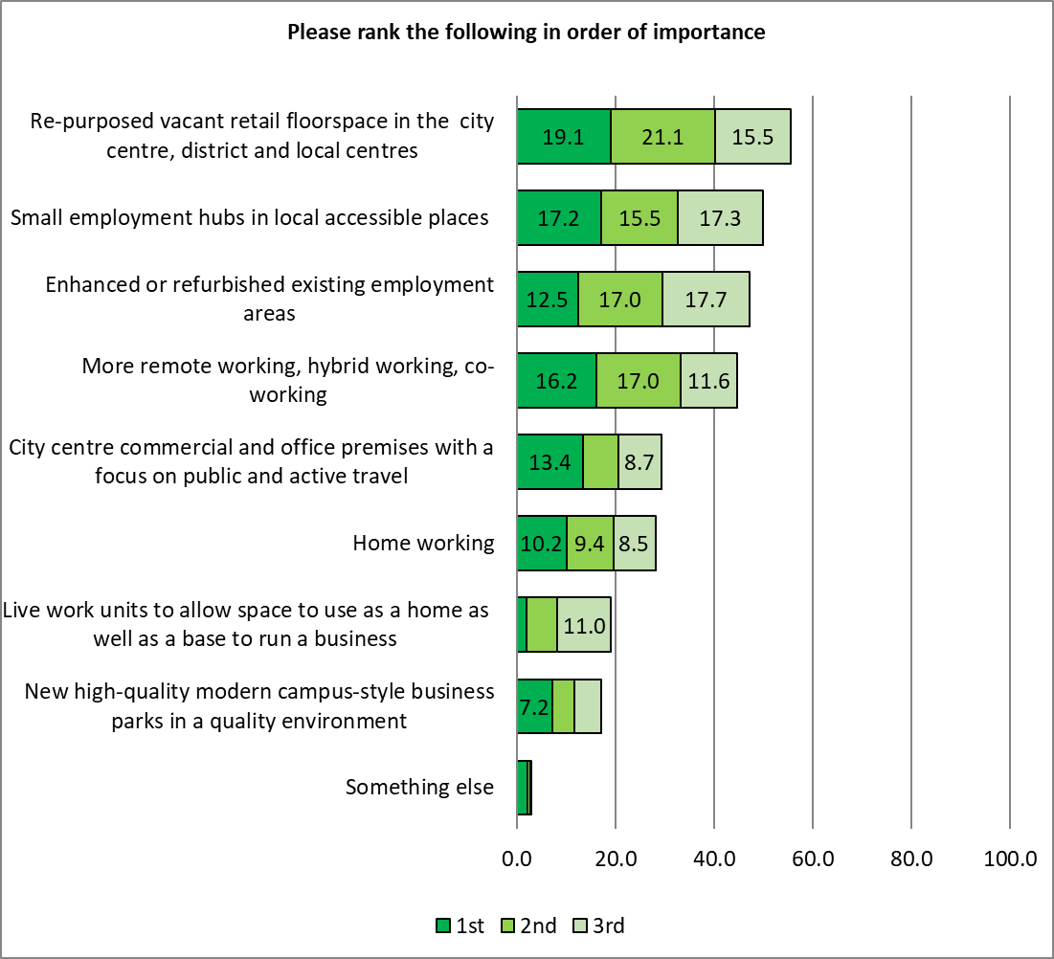
50.0%
47.2%
44.8%
29.3%
28.2%
19.2%
17.1%
3.1%
55.6%
Respondents answering “Something else” were asked to give more details. A total of 136 comments were received, and grouped into themes; the top three themes are shown below, with a full list in Appendix 5:

Theme | No | % | Example comments
Ensure empty properties repurposed | 25 | 18.4 | - use up all existing disused workspace before building new - I’ve seen so many new buildings being erected near an identical building with a "to let" sign  - It surely always makes sense to repurpose and reuse existing spaces before spending money on brand new out of town places usually with no close resources  - Less destruction of our old buildings and architecture.
Improve transport | 19 | 14.0 | - Free travel for all to reduce carbon footprint  - Good public transport at all hours.
Working from Home | 17 | 12.5 | - Allow people to work from home.  - Supported home working by choice

There was a broad consensus of opinion across the demographic groups analysed, with some notable exceptions:

Re-purposed vacant retail floorspace in the city centre, district and local shops
- Support highest amongst respondents from a Minority Ethnicity, with 62.5% ranking this in their top three most important options.
- Support lowest amongst younger respondents, of whom 46.7% ranked it in their top three.

More remote working, hybrid working, co-working
- Support highest amongst those from a Minority Ethnicity, with 65.3% ranking this in their top three
- Support lowest amongst with respondents identifying as disabled (36.8%) and over 55s (37.2%)

New, high quality modern campus style business parks in a quality environment
- Around a fifth of men, those identifying as disabled, and respondents aged 55 or over ranked this in their top three (22.5%, 21.8% and 20.2% respectively), around double the proportion of respondents with children in their household (11.6%), under 35s (11.2%) and women (9.8%).

Home working
- Over a third of respondents living in the most deprived areas of the city (37.9%) ranked this in their top three

A full breakdown of differences by demographic group is available in Appendix 6

Topic 3: New Infrastructure to support growth

Issue: Priorities for new infrastructure
As Cardiff continues to grow, new infrastructure will be needed alongside the new homes and jobs. This will include a wide range of community facilities such as schools and health centres as well as transportation solutions.

The plan must set out the things the city needs and how these can be put in place over the next 15 years.

Please rank the following themes in order of importance
A total of 953 respondents gave at least one answer for at least one option to this question, giving an overall response rate of 78.4%
Transport and Highways were seen as the most important priority for infrastructure, with around two-thirds of respondents (64.5%) ranking this in their top three, with 37.7% rating this as the most important priority.
This was followed by Health, placed in the top three by 57.5% of respondents, and ranked first by 19.7%, then by Green Infrastructure, in the top three of 51.2% of respondents overall, with 17.2% ranking this as most important.
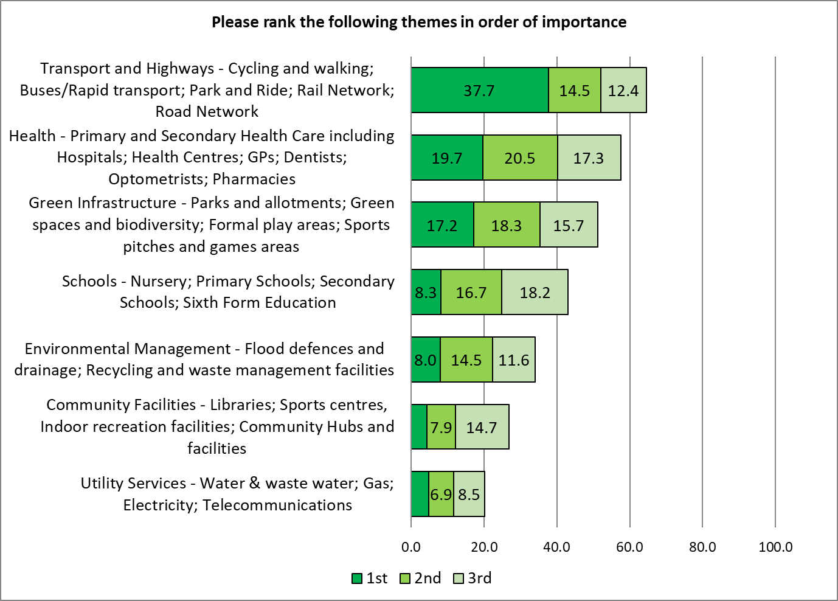
64.5%
57.5%
51.2%
43.1%
34.1%
26.9%
20.3%

Respondents were asked to list any other facilities not included in the above list – 206 comments were received, which were grouped into themes. The top three themes are shown below, with a full list available in Appendix 7.

Theme | No | % | Example comments
Difficult to rank | 42 | 20.4 | - It is very hard to rank infrastructure all of which is essential to a functioning community. Infrastructure should be planned as a whole and no one element is more important than the other. Getting the infrastructure RIGHT is key  - They are obviously all important!  - No - they are all equally relevant. You cannot rank them!
Transport | 38 | 18.4 | - Accessible transport.  - how about overhead mono rail system following existing road  - Electric car charging infrastructure
Road Network | 31 | 15.0 | - Good roads for logistics and to bring more businesses to wales  - Spend more for the car  - The road network needs dramatically improving, ring roads etc.

There were notable differences in priority across the demographic groups analysed, with
- Men were most likely to rate Transport and Highways in first place
- Schools were most important to respondents with children in their household
- Health infrastructure was most important to respondents who identify as disabled
- Green Infrastructure was seen as more important by those under the age of 35

A full breakdown showing differences of opinion is available in Appendix 8

Topic 4: Tackling the Climate Emergency

Issue: How to tackle the climate emergency
Climate change is now widely regarded as one of the most significant global challenges: almost 200 governments have endorsed the Paris Agreement to limit global temperature rise and Welsh Government has committed to reducing emissions of greenhouse gases by at least 80% by 2050.

In recognition of the risks posed to local residents Cardiff Council has declared a climate emergency. If no action is taken, threats such as rising sea levels/increased risk of flooding from rivers and surface water, more frequent extreme weather events and reduced biodiversity and food productivity become ever more critical.

Respond to the climate emergency presents opportunities as well as risks, for example new jobs in green industries; reduced fuel poverty and improved health that comes with better housing; improved air quality and greater active travel.

The plan offers a significant opportunity to take further steps in tackling climate change whilst providing a climate resilient development plan for Cardiff.

How do you think the plan can tackle climate change?
A total of 766 responses were received for this question, which have been grouped into themes. The top three themes are shown below, with a full list available in Appendix 9.

Theme | No | % | Example comments
Renewable energy / sustainable infrastructure | 168 | 21.9 | - Serious investment is needed to provide sound infrastructure for green energy. There should be a mandate placed on housing developers to provide charging points for all homes.  - Energy efficient new homes. Improve energy efficiency of existing housing  - Ensuring all new build / infrastructure is built with sustainability in mind. People's homes are increasingly becoming workplaces too - ensure that new homes are fit for this purpose and allow people to live sustainable lives.  - All public buildings should generate own energy - solar panels etc.  - Focus on zero carbon buildings and on low-carbon heating.
Improved / Enhanced Public Transport / Infrastructure | 149 | 19.5 | - Reduce journeys by fossil fuel vehicles  - The plan should consider more strategic action on traffic and transport  - Cheaper, faster, more reliable greener public transport with plenty of space to avoid overcrowding if looking to reduce the number of cars around the city. Incentivise the use of public transport by making it low cost and affordable.  - Massively increase infrastructure for active transport and reduce city car use.  - Green transport.
Reduce car use - Ban Cars / Sufficient local amenities | 109 | 14.2 | - Facilitating shift from car dependence through improved public transport options to all areas of the city.  - Incentivise people to give up their cars  - Less cars on the streets  - Cut down on private vehicle use  - Develop "15 minute communities" where work, shops, health & community centres are all within 15 mins walk for everyone - discourage motorised transport.

Topic 5: Moving around the city

Issue: Modal split target
As Cardiff continues to grow, new transport infrastructure such as the South Wales Metro will be needed alongside the new homes and jobs. It is important that this seeks to reduce reliance on the car in order to reduce congestion and harmful emissions and seek to promote a modal shift to sustainable forms of travel such a buses and trains, and active travel such as walking and cycling.

Latest data shows that the modal split in the city is currently around 50% private car/sustainable forms of transport.

As the city grows, what degree of modal split should the plan seek to achieve between private car use and sustainable forms of transport?
A total of 1,031 responses were received for this question, giving a response rate of 84.9%
A fifth of respondents (19.4%) indicated that the plan should seek to prioritise sustainable forms of transport, compared with 4.3% prioritising private car use, with 12.2% favouring a balance between the two.
Scores were calculated according to the number of respondents giving each answer, with lower scores favouring private car use, and higher scores favouring sustainable forms of transport – an overall score of 58.3 was achieved, indicating a balance between the two, slightly favouring sustainable transport.

Respondents identifying as disabled were the only demographic group analysed to shift the balance in favour of private car use:
Base sizes shown in brackets – caution should be taken with lower base sizes

There was no clear pattern across areas with different levels of deprivation.

Issue: Delivering Sustainable Transport Infrastructure
In order to deliver a modal shift and reduce congestion and reliance on the car it will be important for the plan to provide for a range of sustainable forms of transport.

Please rank the following options in terms of where you think we should invest infrastructure resources
A total of 923 respondents gave at least one answer for at least one option to this question, giving an overall response rate of 76.0%
Almost three-quarters of respondents (72.5%) rated investing in bus infrastructure within their top three priorities, with 32.6% ranking this as most important.
Two-thirds (66.4%) prioritised investing on train infrastructure, with 19.2% rating this as the most important priority.
Both cycling and walking were ranked in the top three by over half of those responding to this question (54.4% and 51.2% respectively).

Looking at these results by the different demographic groups showed different priorities.

Amongst respondents aged 55 or over, 84.3% ranked investment in bus infrastructure in their top three priorities, compared with 55.0% of those under 35.

Younger respondents put more emphasis on active forms of travel, with 70.3% prioritising investment in cycling, and 60.4% in walking compared with 46.5% and 48.2% of older respondents, respectively.

Respondent living in the more deprived areas were more likely to prioritise investment in cycling and walking than more affluent areas. Respondents living in the least deprived areas were more likely to place a higher priority on investment in train infrastructure.

Charts showing these difference in detail are available in Appendix 10.
Please specify where else infrastructure resources should be invested

A total of 268 responses were received for this question, which have been grouped into themes. The top three themes are shown below, with a full list available in Appendix 11.

Theme | No | % | Example comments
Improved / Enhanced Public Transport / Infrastructure | 109 | 40.7 | - Bus service in Cardiff is appalling.  - New train stations are essential. There are so many existing lines that run through the city for miles without intermediate stops. Take London – all central rail and tube lines have stations that are 15-20 minutes walk apart. That should be the ambition for all existing lines within all urban areas.  - Regular and cheap metro / trams  - Have one payment system that's allows train and bus use combined  - One ticket system to cover public transport, parking and cycle hire
Road Infrastructure | 35 | 13.1 | - The existing roads need maintenance and improvement to ensure they are still fit for purpose.  - We must recognise that the global pandemic has led people to want to use private transport for their travel needs, the obsession with public transport will cost us dearly in the future, and is not in line with personal needs.  - good roads and pavements - that will enable people to cycle and walk safely as well as drive
Focus on reducing need to travel / Car free areas | 20 | 7.5 | - Cars need to be actively discouraged and prevented  - Car-free areas - big ones!

Topic 6: Heathier Environments

Issue: Improving health and well-being
Across Cardiff, inequalities exist both in terms of health and deprivation. For despite Cardiff’s economic growth during the last 30 years, the patterns of poverty and inequality that emerged a generation ago remain. Over 150,000 people in the city live in some of most deprived communities in Wales. In terms of health, there is an 11 year gap in life expectancy for men and a 9.2 year gap in life expectancy for women between our most deprived and our least deprived communities. In addition, 54% of the population of Cardiff is either overweight or obese.

Given this it is important that the plan provides an appropriate balance and ensures that improving people’s health is a key consideration in new and existing developments across the city. A range of measures for the plan to consider are listed below.

How do you think the city could be a healthier place and improve wellbeing?
A total of 903 respondents gave at least one answer for at least one option to this question, giving an overall response rate of 74.3%
The most important action to make the city a healthier place, and improve wellbeing, was to give Improved Access To Green Space, ranked in the top three options by 53.2% of respondents, and as the single most important by 24.5%.
This was followed by Feeling Safe, with 36.8% putting this option in their top three (12.8% ranking it first), then by Improved Air Quality, which was selected by 35.5% of respondents, ranked first by 11.2%.

These results were also analysed by demographic group – women were most likely to rank Feeling Safe in their top three (41.6%), closely followed by respondents with children in their household (41.2%); less than a quarter of respondents under the age of 35 ranked this as one of their top three options.
Respondents living in the more deprived areas of the city were a little more likely than those in more affluent areas to rank Feeling Safe in their top three.
More Walking Routes were more likely to be selected as an option to make Cardiff a healthier place and improve wellbeing, along with respondents living in more affluent areas of the city. Younger respondents were also more likely to select More Cycling Routes than other demographic groups.
Over a third of respondents who identify as disabled (36.4%) wanted to see Improved Access to Fresh Food.
Respondents under the age of 35 were notably less likely to think More Control Over Fast Food Takeaways would make the city a healthier place, with just 7.3% pf respondents in the age groups selecting this option, contrasting with 26.8% of those over the age of 55.

A full breakdown of difference by demographic group is shown in Appendix 12.

Please specify what else you consider to be important
A total of 170 responses were received for this question, which have been grouped into themes. The top three themes are shown below, with a full list available in Appendix 13.

Theme | No | % | Example comments
Better awareness / education | 26 | 15.3 | - Awareness raising/education regarding the benefits of more healthy lifestyles (e.g.: Bristol Eating Better campaign).  - Better education regarding health issues in our primary schools, how to keep fit and healthy.  - Fresh food is available but people are lazy or not taught. Home economics should be back on the curriculum and also taught in hubs
More / Better community infrastructure / Facilities | 24 | 14.1 | - Investing in more community projects and youth groups and creating activities for young people and elderly.  - We keep building houses but no amenities to improve wellbeing, e.g. Plasdwr should include tennis courts, football pitches, a lido.  - Social isolation is a killer. We need better small scale social infrastructure and more community infrastructure, things like community food gardens (think Incredible Edible).
Retain / More Green Spaces | 19 | 11.2 | - Encourage use of green spaces and allow all homes to have a safe local place to exercise and enjoy nature helping mental and physical health  - Need to protect and not destroy existing green areas, without the protection of these sites CCC will not have the best interests of the Environment at heart

Topic 7: Supporting the roles of the City Centre and Cardiff Bay

Issue: Future role of city centre
Cardiff city centre and Cardiff Bay play a key retail, economic and tourism role for the city and South East Wales. Supporting the role of the city centre and the continued regeneration of Cardiff Bay are key issues for the plan to address. In addition the plan will need to respond to the impacts of the Covid pandemic on high street retailing, the demand for traditional office accommodation and encourage more mixed uses within the city centre in addition to supporting its key retail role.

Overall, the plan provides an opportunity to consider how the city centre can continue to evolve and play a key role in the future of the city.

What do you think the future role of the city centre should be? Tick all that apply
A total of 962 responses were received for this question, giving a response rate of 79.2%
More than four in five respondents felt the future role of the city centre should be For Entertainment (89.4%), For Shopping (86.5%) and For Hospitality (84.4%).
Just over half (55.6%) felt it should be For Offices, and just under half (48.4%), For Homes.

Percentages do not total 100% as respondent were able to select multiple responses

Younger respondents, and those from a Minority Ethnicity were most likely to indicate the city centre should be used for Entertainment or Hospitality, contrasting with respondents who identify as disabled, and those aged 55 or over.
There was a correlation seen between level of deprivation and those thinking the city centre should be used for Hospitality, with more affluent areas more likely to see a role for Hospitality for the city centre in the future.
Respondents living in more deprived areas were more likely to see Homes as a future role for the city centre.
Older respondents were more likely to suggest Homes as a future for the city centre than respondents aged under 35.

Charts showing these breakdowns by demographic are available in Appendix 14.

Something else
Respondents answering “Something else” were asked to give further details. A total of 82 responses were received, and grouped into themes. The top three are shown below, with a full list available in Appendix 15

Theme | No | % | Example comments
Attractions / Tourism - Music / Murals / Arts / Culture / Sporting Events etc. | 25 | 30.5 | - Interesting, unique attractions that differentiate Cardiff from any other UK city. There aren't enough well developed cultural attractions.  - Arts and culture - music, murals, worships, creativity!
Community Spaces / Socialising areas / Using Green Spaces | 21 | 25.6 | - A social gathering place for all ages and communities  - As a rich living green centre with gardens, a sanctuary for animals - a re-greening centre as a sanctuary for citizens.
More Amenities | 13 | 15.9 | - Leisure, sports, green spaces, health centre/dentist, community education, cycle paths, a Green healthy city  - Creative production. Fitness and leisure. Education. Mixed use of all kinds, including those not yet imagined. Flexibilty and adaptability.

In the future, how often would you be likely to use the following in the city centre for each of the following?
Between 216 and 940 responses were received for the options included in this question, giving response rates between 17.8% and 77.4%
Respondents were more likely to use the city centre in the future as a venue to meet family and friends (45.7%), followed by Culture/Tourism (42.5%), Hybrid Working (41.8%) and Entertainment/Leisure (41.2%).
Just 24.1% of respondents indicated they would be likely to use the city centre for shopping in future compared with 34.1% stating they would be less likely to go shopping in the city centre in the future.
Almost two-thirds (64.8%) suggested they would be less likely to be working at an office in the city centre in future, compared with just 7.0% who felt this was more likely.

Base sizes shown in brackets – caution should be taken with lower base sizes

Respondents under the age of 35 were most likely to indicate they would be more likely to use the city centre:
- As a Place to Meet Family and Friends (67.2%.compared with 38.1% of those aged 55 or over)
- As a place for Entertainment/Leisure (61.2%, compared with 32.2% of those aged 55 or over)
- For Hospitality (47.8%, compared with 28.9% of those aged 55 or over)
- For Culture/Tourism (57.8%, compared with 35.7% of older respondents)

Respondents identifying as disabled were most likely to indicate they would use the city centre for shopping in the future (38.5%).

A full breakdown by demographic group can be found in Appendix 16.

For what other purpose would you use the city centre?
Respondents were asked if there were any other purposes for which they would use the city centre: 66 responses were received, and grouped into themes. The top three are shown below, with the full list shown in Appendix 17.

Theme | No | % | Example comments
Commuting/Travel | 11 | 16.7 | - To commute into/out of  - As a transport hub.
Exercise | 9 | 13.6 | - Exercise. The river is an amazing place for swimming and kayaking. Can we make more of our waterways as places for exercise?  - For a stroll
Green space | 9 | 13.6 | - To enjoy green space - i.e. the castle  - Enjoying green spaces like Bute Park, Cardiff Castle, walking by the river, boat trips, being able to pop for a coffee and some relaxation time somewhere quiet and pretty and not crowded

Topic 8: Post Pandemic Recovery

Issue: Helping the city recover from the pandemic
As the city recovers post-pandemic, the plan provides an opportunity to consider those areas of land use policy which require a new or amended approach to explicitly address the implications of the pandemic on the way we work, live, enjoy and move around the city. The concept of the 15 minute city has been proposed where all facilities are located within a 15 minute radius encouraging walking and cycling and less reliance on the car.

The plan provides an important opportunity to revisit existing policy approaches.

Please rank the following new or amended policy approaches in order of importance in responding to the pandemic
A total of 854 respondents gave at least one answer for at least one option to this question, giving an overall response rate of 70.3%
“Staying local – Creating 15 minute neighbourhoods” was rated as the most important policy approach to respond to the pandemic, with half (50.0%) of those responding to this question placing it in their top three, with 28.6% rating it as the single most important approach.
The pandemic also reinforced the importance of access to green spaces, with 41.2% of respondents choosing this approach as one of their top three.

There was generally a consensus of opinion across the demographic groups analysed, with a small number of notable differences:
Under 35s placed the highest level of importance on Active Travel (with 47.7% placing this in their top three), followed by men (46.0%, compared with 36.8% of women).
Respondents aged 55 or over, men, and those identified as disabled placed the highest importance on “Revitalising the city centre, and district and local centres”, with over 40% of each group placing this in their top three most important policy approaches, compared with around a quarter of respondents aged under 35, or those with children in their household.
More than half of women (52.6%) placed “Renewed importance of access to green spaces” in their top three most important actions, compared with 36.8% of men.
There were no significant differences of opinion by level of deprivation.

A full breakdown of differences by demographic group can be found in Appendix 18.

Please specify what else you consider to be important
Respondents answering ‘Other’ were asked to give more information: 69 responses were received, and grouped into themes. The top three are shown below, with a full list in Appendix 19

Theme | No | % | Example comments
New Approach | 12 | 17.4 | - Change the way Cardiff manages parks & verges to rewilding & local food, low maintenance approach  - Place people and planet at the centre of every decision, above all else!
Improve Neighbourhoods / Encourage people to use local amenities / facilities | 11 | 15.9 | - Having attractive local neighbourhoods with good transport links and local amenities.  - Investment in exciting children's play - eg. playgrounds including more money for maintenance.
Improved Road Infrastructure | 8 | 11.6 | - The use of electric cars is growing exponentially, take much more account of that in the plans

Topic 9: Creating places where people want to live, work or explore

Issue: Creating good places
It is important that the plan creates places where people want to live, work and explore. This involves identifying what people like about a place and how it can be improved through considering factors such as design, location, infrastructure and above all, the needs of people you’re creating the place for.

What do you think is good about your neighbourhood?
A total of 904 respondents gave an answer this question, giving a response rate of 74.4%
Respondents were given a list, and asked to indicate which they felt applied to making their neighbourhood a good place to live.
The most common response, selected by almost three-quarters (73.1%) of respondents, was “Outdoor activities/open space/parks”.
This was followed by “Close to public transport” (69.5%), a “Pleasant walking environment” (63.6%), and “Safe (low crime rate”), chosen by 61.5% of respondents.
Three in ten (29.1%) cited “Good community facilities/activities). 23.1% “Good cycling routes”, and 12.6% stated there was “Good childcare provision”.
Percentages do not total 100% as respondent were able to select multiple responses

There were some key differences across the demographic groups analysed.

Respondents living in the Southern Arc of Cardiff were less likely than other groups to list:
- “Outdoor activities/open spaces/parks” (66.7%)
- “Pleasant walking environment” (53.3%)
- “Safe (low crime rate)” (41.9%)
- “Good schools” (31.4%)
- “Family friendly” (36.2%)

Respondents living in the more deprived areas were notably less likely than those living in more affluent areas to cite:
- “Pleasant walking environment” (40.3% in the most deprived areas, compared to 69.7% in the least deprived areas)
- “Safe (low crime rate)” (25.8% in the most deprived areas, compared with 79.8% in the least)
- “Good health facilities” (29.0% in the most deprived areas compared with 43.3% in the least deprived areas)

Men were most likely to describe their neighbourhood as “Safe” – 66.7% compared with 57.1% of women.
Respondents with children in their household were most likely to cite “Good schools” (64.5%), “Family friendly” (57.5%), and “Good childcare facilities” (21.5%)
Older respondents were most likely to state “Good health facilities” (46.0%), “Good community facilities/activities” (32.3%)
Respondents from a Minority Ethnicity were least likely to cite “Good health facilities” (28.6%) or “Good community facilities/activities” (23.8%)
Around three in ten respondents from a Minority Ethnicity, or aged under 35 cited “Good cycling routes”, compared with 18.5% of those aged 55 or over.
A full breakdown by demographic and geographic groups can be found in Appendix 20.

Respondents answering ‘Something else’ were asked to specify what this was: 47 responses were received, and grouped into themes. The top three are shown below, with a full list in Appendix 21.

Theme | No | % | Example comments
Proximity / Accessibility / Close to Local Amenities / Facilities | 18 | 38.3 | - Good location to get to various locations.  - Allotment, which is a great place to take grow your own food and get a good workout doing it!  - Plenty of choice of places of worship.
Negative Comments | 12 | 25.5 | - Nothing is good we feel scared unsafe and minoritised and surrounded by crooks drug dealers and nasty creatures  - Not an area I would choose if I could afford to move
Community Spirit | 7 | 14.9 | - Diversity within the community.  - The good thing about my neighbourhood is the community, the people.

What do you think could be done to improve your local neighbourhood?
A total of 868 responses were received for this question, giving a response rate of 71.4%
Respondents were then asked what could be done to improve their local neighbourhood.
The biggest response was “Provide good community facilities/activities”, mentioned by 47.1% of respondents.
Two-fifths of respondents (40.1%) wanted their neighbourhood to be made safer, and 37.3% wanted the provision of good cycling routes.
Percentages do not total 100% as respondent were able to select multiple responses

There were some notable differences across the demographic groups analysed.
Respondents identifying as disabled and those from a Minority Ethnicity were most likely to call for the provision of good community facilities/activities (60.2% and 59.3% respectively).
Men were less likely to feel the provision of good community facilities/activities would improve their neighbourhood (43.8%, compared with 53.0% of women)
Respondents under the age of 35 were most likely to cite the provision of good cycling routes would improve their neighbourhood, compared with 30.2% of those aged 55 or over. They were also more likely to want the provision of outdoor activities/open spaces/parks (39.7%), and of closer public transport (36.2%).
Around a third of respondents from a Minority Ethnicity, and those with children in their household, wanted their neighbourhood to be made more family friendly (32.1% and 31.3% respectively).
Respondents identifying as disabled were least likely to feel their neighbourhood could be improved by:
- Provision of good cycling routes (25.0%)
- Provide a pleasant walking environment (28.4%)
This group was more likely to cite “Provide good health facilities” (52.3%), and provision of closer public transport (35.2%)
Those living in the Southern Arc of the city were more likely to feel their neighbourhood could be improved by:
- Making it safer/lower crime rate (61.9%)
- Provide a pleasant walking environment (47.4%)
- Provision of outdoor activities/open spaces/parks (39.5%)
Looking at opinions by areas of differing levels of deprivation, some notable differences were identified:
- 82.8% of those resident in the most deprived areas wanted their local neighbourhood to be safe, compared with 17.6% of those living in the least deprived areas
- 45.3% of those in the most deprived areas wanted the provision of outdoor activities/open spaces/parks compared with 27.1% of those in the least deprived areas
- 43.8% in the most deprived areas wanted their neighbourhood to be more family friendly, compared with 18.1% of residents in the most affluent areas
- 29.7% of those living in the most deprived areas wanted good childcare provision, compared with 11.8% of those in the least deprived areas.
A full breakdown of these results is available in Appendix 22.

Respondents answering ‘Something else’ were asked to give further details. In total, 117 responses were received, which have been grouped into themes. The top three are shown below, with a full list in Appendix 23.

Theme | No | % | Example comments
More / Improved Local Amenities / Facilities | 26 | 22.2 | - Community gardens and farmers markets. More sports facilities. Car charging points.  - Make children’s playgrounds more exciting by adding more equipment; Change policies to not allow neighbours moving close to existing parks and playgrounds to have equipment removed due to noise etc.  - We only have big supermarkets - no small neighbourhood shops. Hence people drive more, and few focal points exist for the community
Retain / Protect Green Spaces | 18 | 15.4 | - Not decimate our neighbourhood by taking away our peace, quiet and tranquillity. Preserve our air quality, green space, nature and wildlife.  - Stop building on green belt land destroying habitats and green space.
Improve Litter Issues | 17 | 14.5 | - More bins & cleaning of the streets. Fine people who leave rubbish in their front gardens.  - More street cleaning and drain maintenance. Bins that the seagulls can’t get into!

Topic 10: Protecting Green and Blue Infrastructure

Issue: Green Spaces
Green spaces play an important role as a place for recreation, walking, cycling, etc. and it is important there are sufficient and accessible green spaces in the city for both residents physical and mental health. They also provide an important habitat to support wildlife and biodiversity.

In providing for future growth the plan will need to find an appropriate balance towards protecting green spaces and meeting the need for new homes and jobs.

How do you think the plan should find this balance?
A total of 905 responses were received for this question, giving a response rate of 74.5%
Just over half of those responding to this question (52.0%) felt that “all green space should be protected, even if that means houses, schools, infrastructure cannot be provided”; 44.0% felt that “green space should only be allowed to be lost if a clear social benefit is gained, such as the building of a new school or social housing, and if replacement green space is provided”.
Just 4.0% suggested that “green space can be lost for most development if absolutely necessary”.

Older respondents, and women, were most likely to support the protection of green spaces at the expense of the provision of new infrastructure (53.1% and 52.1% respectively); half of those aged under 35 (50.0%) felt that green space should only be lost if there is a clear social benefit, and replacement green space is provided

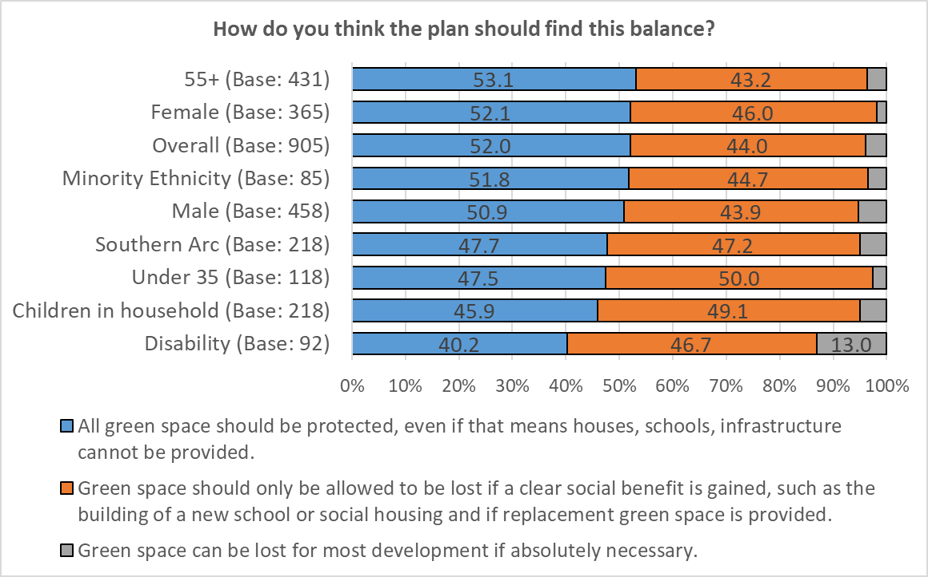
Base sizes shown in brackets – caution should be taken with lower base sizes

There was a correlation in answer by the level of deprivation, with those living in more deprived areas more likely to support the loss of green space for the gain of a clear social benefit, and replacement of the green space, whilst those in the more affluent areas were more likely to feel that green space should be protected at the cost of new infrastructure.

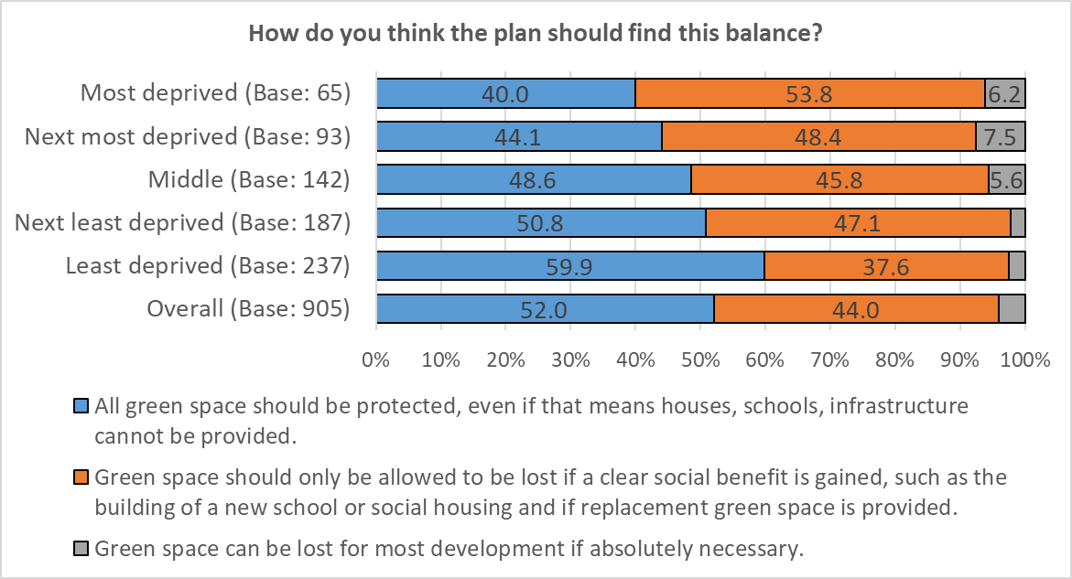 Base sizes shown in brackets – caution should be taken with lower base sizes
What other approaches would you suggest?
A total of 308 responses were received for this question, which have been grouped into themes. The top three themes are shown below, with a full list shown in Appendix 24.

Theme | No | % | Example comments
Green Spaces To Be Protected | 78 | 25.3 | - Use of green space should only be sanctioned as a last resort when all other options have been exhausted and the decision making scrutinised to ensure it is the case.  - Green spaces need to be protected and increased, there are enough brown field sites that can be redeveloped into housing.  - Too much green space already used  - Given the climate and biodiversity emergencies, there’s no question now that all green space must be protected and alternative approaches taken. Perhaps we need to obsess less about growth and focus more on preservation - we cannot keep on infinitely growing - the planet can’t take it
Develop / Re-use Existing Buildings / Space | 61 | 19.8 | - I cannot see the point of creating 'new' green spaces to replace existing, just be more creative about where to build what is deemed necessary  - Green space only as last resort. Make use of existing built up spaces.  - Always look for areas that need updating and can be "recycled" for other use before taking any green spaces away. These green spaces are vital to people's wellbeing but more importantly to nature and we are losing too much already.  - Use brown land, rebuild or update empty houses
Develop / Use Brownfield Land | 47 | 15.3 | - Build on brown sites  - Prioritise brownfield development and repurposing of existing redundant building  - Better use of brownfield areas. Incentivise developers to use infill areas

Issue: Nature and Trees
Trees play a key role in tackling climate change through their role as carbon sinks and also provide an important habitat to support woodland wildlife and biodiversity.

In providing for future growth the plan will need to find an appropriate balance towards protecting trees and meeting the need for new homes and jobs.

How do you think the plan should find this balance?
A total of 911 responses were received for this question, giving a response rate of 75.0%
Over half (56.1%) of those responding to this question felt that “trees should only be allowed to be felled if a clear social benefit is gained, such as the building of a new school or social housing, and if replacement planting is undertaken”, whilst just over a third (38.6%) felt that “no trees should be allowed to be felled, even if that means houses, schools, infrastructure, cannot be provided”.
Just one in twenty (5.3%) stated that “trees can be felled for most development if absolutely necessary”.

Respondents identifying as disabled were most likely to support the felling of trees for a clear social beneift, and if replacement trees are planted (62.% and 60.3% respectively), whilst respondents from a Minority Ethnicity, and those aged under 35 were most likely to state that no trees should be felled, even at the expense of the provision of new infrastructure (45.8% and 40.2% respectively).

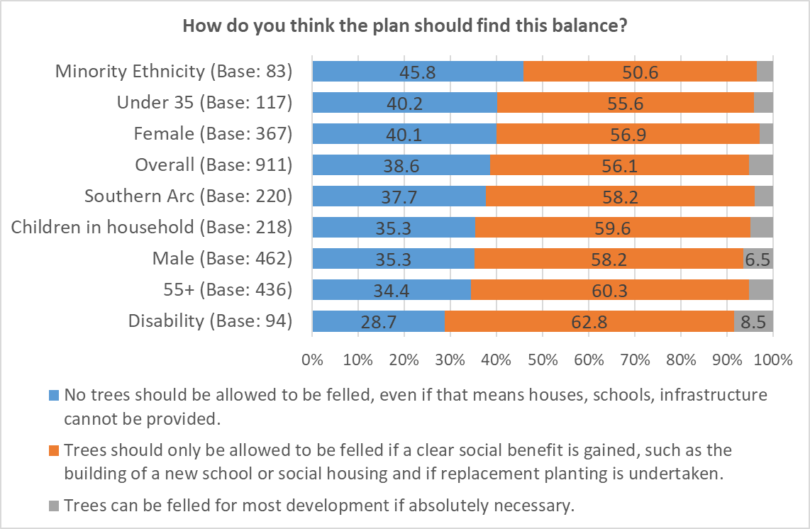 Base sizes shown in brackets – caution should be taken with lower base sizes

There was no clear correlation by level of deprivation:

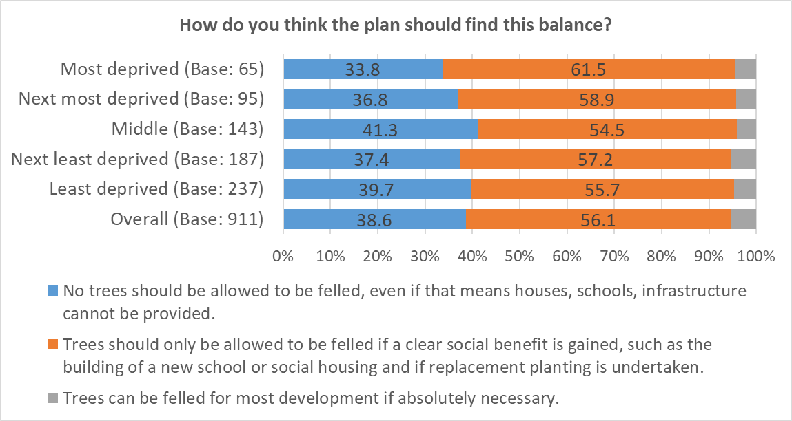 Base sizes shown in brackets – caution should be taken with lower base sizes

Topic 11: Protecting historic and cultural assets

Issue: Historic and cultural assets
As Cardiff continues to change, there is an increasing need to protect, promote, conserve and enhance its historic and cultural assets and recognise the important role they play in the economic, environmental and social fabric of the city.

What measures do you think the plan needs to put in place to protect the city’s historic assets and further enhance and promote the city’s role as a capital city and as an international destination for residents and visitors?
A total of 247 responses were received for this question, which have been grouped into themes. The top three themes are shown below, with a full list in Appendix 25.

Theme | No | % | Example comments
Better transport links | 35 | 14.2 | - Got to sort out public transportation, it is the weak link in Cardiff’s offer  - Cultural facilities in city centre are hampered by bad transport policies  - Reintroduce a central hub for public transport.
Better Art/ Cultural offer | 30 | 12.1 | - A huge focus on culture, of which history is a part, through arts, crafts, and music. Expand the music scene.  - More city wide co-ordination of historic and cultural assets.  - Market Cardiff as a city if historical importance with incredible architecture, culture and make the visiting experience excellent for all ages
Green spaces | 27 | 10.9 | - Green spaces should be legally protected from future developments and to ensure our city does not become a concrete jungle; planning restriction should be tighter to ensure development is in keeping with environment and sustainable infrastructure and biodiversity wise.  - Protect and improve the green areas of the city which are its key attraction

12: Vision and Objectives

The Plan will need to be guided by an over-arching Vision and we are consulting early in the process to share our initial thinking on the Vision for the plan in order to try to build consensus at an early stage and allow time to consider feedback ahead of further stages of engagement.

To create a fairer and more sustainable city by:
- Responding to the urgent future needs for new homes, jobs and infrastructure;
- Positively tackling the challenges of climate change and post-pandemic recovery;
- Creating a greener, more equal and healthier city which is easier to move around and enhances the wellbeing of future generations;
- Using a placemaking approach, working with local communities to improve neighbourhoods and deliver high quality design;
- Looking after our natural, historic and cultural assets

Do you agree with the draft Vision for the plan?
A total of 865 responses were received for this question, giving a response rate of 71.2%
Overall, two-thirds (66.5%) of those responding to this question agreed with the draft Vision for the Replacement Local Development Plan, compared with 16.8% who disagreed.

Highest levels of agreement with the draft Vision came from respondents living in the Southern Arc of the city and those under the age of 35 (each 72.2%). Agreement was lower amongst those aged 55 or over (63.6%).
Base sizes shown in brackets – caution should be taken with lower base sizes

There was no clear correlation for agreement by level of deprivation, however support was highest amongst those in the most deprived areas (74.6%), and lowest amongst those living in the most affluent areas of the city (58.3%).

Base sizes shown in brackets – caution should be taken with lower base sizes

Let us know how you think the Vision could be improved
A total of 428 responses were received for this question, which have been grouped into themes. The top three themes are shown below, with a full list in Appendix 26.

Theme | No | % | Example comments
Stop building new/ expand & repurpose existing infrastructure | 92 | 21.5 | - Tackle developers pulling the city apart. No use holding your hands up and saying "can't do anything, don't want a legal challenge". You would have the support of the public in doing so.  - Need to improve existing housing stock and very carefully look to build new ....more carefully than this vision implies!  - Lose the focus on new homes, renovate and expand existing infrastructure rather than building on new land just because a housing crash  - Reduce the emphasis on expansion. Work with Welsh Government and other local authorities to spread development wider across SE Wales
Climate Change / Cleaner, greener city/protect green spaces | 92 | 21.5 | - Doesn't go far enough about the environment. Tackling climate change should be at the core of every one of the values.  - Its ok to say this but green issues need to be prioritised and scientists listened to  - Not strong enough on the environment, Climate change isn't the only environmental catastrophe we face, our insect population has dropped by over 75% in 27 years.  - I think the priorities are wrong. By having the 'new homes, jobs and infrastructure' at the start, you are already setting a tone for this being given more weight than green spaces and biodiversity.
Improved Transport infrastructure- roads/public transport/accessibility | 49 | 11.4 | - Transport is the only priority. The current thinking of transport capacity lagging demand is a disaster. Transport capacity needs to lead demand. That is to say you must put in the transport infrastructure first. Current policy has almost destroyed the city centre already.  - You must focus on better integrated transport and cycling routes and more greenery in districts. Is there an option for cut and cover road in front of the castle to reopen this back up to pedestrians / public realm whilst keeping the busy road access?  - The focus on active travel needs to go if you want any form of post-pandemic recovery.
The LDP objectives aim to deliver the vision for the plan and respond to the key issues the plan needs to address.

Please rank the draft plan objectives in order of importance
A total of 798 respondents gave at least one answer for at least one option to this question, giving an overall response rate of 65.7%
Tackling Climate Change was seen as the most important of the draft plan objectives, with 45.4% ranking this in their top three, and 27.4% ranking this as the single most important.
This was followed by Healthier Environments, ranked in the top three by 38.8%, and first by 6.0%, and Protecting Green & Blue Infrastructure, ranked in the top three by 36.3%, and first by 10.2%.
Supporting the roles of the city centre and Cardiff Bay was seen as least important of the objectives listed, ranked in the top three by just 6.9% of respondents, and first by just 1.3%.

There were differences of opinion across the different demographic groups analysed.

Respondents under the age of 35 were most likely to rank “Tackling Climate Change” as their most important objective, with 33.6% ranking this as the single most important objective, and 57.9% placing it in their top three. They were also more likely than average to place importance on “Moving around the City”, with 32.7% ranking this in their top three.

Respondents over the age of 55 placed less importance on “Tackling Climate Change”, with 38.2% placing this in their top three most important objectives.

Women were more likely to include “Tackling Climate Change” (50.8%), “Healthier Environments” (44.8%) and “Protecting Green and Blue Infrastructure” (42.9%) in their top three; men were more likely to include “Provision of new infrastructure to support growth” (32.5%) and “Moving around the City” (31.8%).

Those identifying as disabled were more likely to support objectives to “Provide new houses and homes” (34.5%), “Post-pandemic recovery” (35.6%), and “Provision of infrastructure to support growth” (35.6%).

Respondents with children in their household were more likely to include “Tackling Climate Change” (53.3%) and “Healthier Environments” (46.2%) in their top three most important objectives

Those living in the most deprived areas of the city placed more importance on “Creating places people want to live, work and explore” (34.5%), “Provide new houses and homes” (29.1%) and “Provide new jobs and employment (23.6%). Those living in the least deprived areas placed higher importance on “Protecting green and blue infrastructure” (39.8%) and “Supporting the roles of the City Centre and Cardiff Bay” (9.5%).

A full breakdown is available in Appendix 27.

Would you add any other objectives?
A total of 208 responses were received for this question, which have been grouped into themes. The top three themes are shown below, with a full list available in Appendix 28
Theme | No | % | Example comments
Greener city | 27 | 13.0 | - Moving around the city in a sustainable way  - Biodiversity should be key  - Creating a more beautiful and less generic looking city.
Improved Transport infrastructure- roads/public transport/accessibility | 27 | 13.0 | - Should not be any new homes until infrastructure has been put in place to cope with the 10,000 that have been built in last 8 years  - The more equal city mentioned in the Vision is not in the Objectives I've noticed. Why's that?  - Transport, transport, transport. The Metro plan must be front and centre of the LDP. All new developments must be Metro-centred, not built without consideration with a bus service added as an afterthought to an already congested roads. Public transport must be fast, clean, reliable, 24hr, cheap, safe. And make the developers pay for it.
Question concerns / Queries | 22 | 10.6 | - Again, ranking these is difficult. They all have to work well and together to achieve the vision.  - I've no idea what Blue infrastructure means  - These are a list of aspirations NOT reality! The net is far too wide and as a result, little will get done!

13. Additional Comments
Do you have any other comments?
A total of 275 responses were received for this question, which have been grouped into themes. The top three are shown below, with a full list at Appendix 29.

Theme | No | % | Example comments
Protect Green Spaces / Address Climate Emergency | 48 | 17.5 | - Address the climate emergency and stop destroying green spaces  - Protect our green spaces and heritage. Cardiff is in danger of being destroyed by developers.  - Cut out the obsession with building on greenfield sites  - We need to be serious about tackling climate change. It is important that short term gain does not take priority over long term solutions.
Survey Concerns / Consultation will be ignored | 32 | 11.6 | - It makes little difference what is said as you do as you like anyway  - Not really sure why you have bothered to ask as Cardiff Council will already have done deals with developers!  - I realise my completing this questionnaire is a pointless and you will do what you want anyway. I do wonder why you bother to seek public opinion and then ignore it. Just more "box ticking" Sadly.
Planning concerns | 28 | 10.2 | - I would like to see more powers of objectivity in the planning department. They need better controls over quality and design of new builds to protect the city’s skyline.  - Do not make Cardiff look like every other city with too many ugly high rise buildings.  - Stop allowing developers to build all this poor quality student accommodation. It’s a disgrace to the city centre. Raise standards in building design

Appendix 1 – Demographic Profile of Respondents

Please provide your full postcode
A total of 746 respondents provided their postcode. The map below shows the location of complete postcodes within Cardiff.
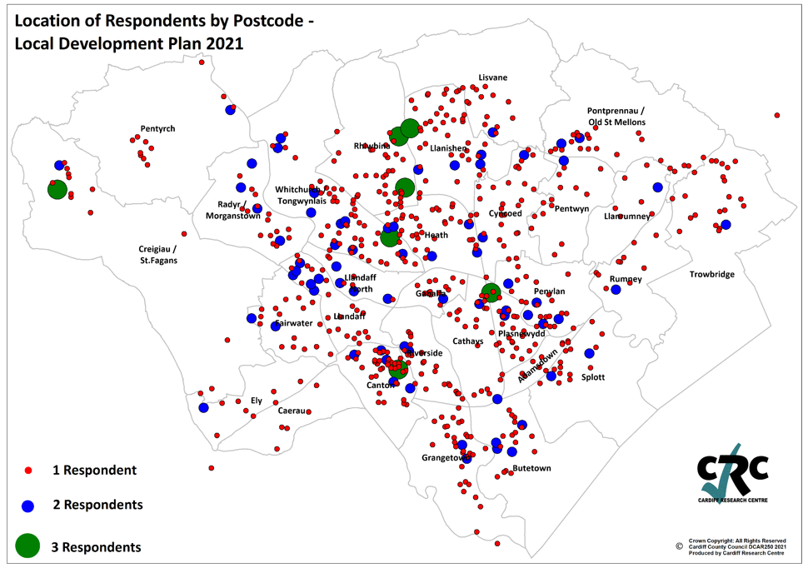

Of these, 222 respondents were identified as being resident in the Southern Arc of Cardiff.
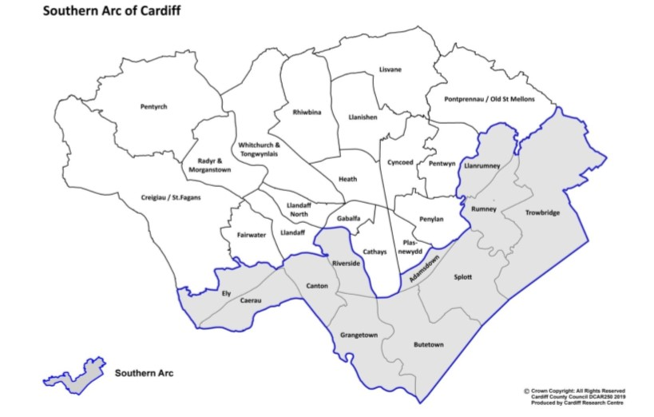

What was your age on your last birthday?
 | No | %
16-24 | 14 | 1.6
25-34 | 105 | 11.9
35-44 | 145 | 16.4
45-54 | 157 | 17.8
55-64 | 203 | 23.0
65-74 | 176 | 19.9
75+ | 60 | 6.8
Prefer not to say | 23 | 2.6
 | 883 | 100.0

Are you…?
 | No | %
Female | 369 | 41.9
Male | 467 | 53.0
Other | 1 | 0.1
Prefer not to say | 44 | 5.0
 | 881 | 100.0

Do you identify as Trans?
 | No | %
Yes | 2 | 0.2
No | 793 | 93.0
Prefer to self-describe | 6 | 0.7
Prefer not to say | 52 | 6.1
 | 853 | 100.0

Do any children live in your household?
 | No | %
No children | 638 | 74.1
Yes, under 5 years old (pre-school) | 57 | 6.6
Yes, aged 5 - 11 (primary school) | 102 | 11.8
Yes, aged 11 - 16 (secondary school) | 64 | 7.4
Yes, aged 16 - 18 in full-time education, or working | 62 | 7.2
Yes, aged 16 - 18 but not in full time education or working | 9 | 1.0
 | 861 | -

Which of the following best describes what you are doing at present?
 | No | %
Working full time (30+ hours per week) | 422 | 47.8
Working part time (less than 30 hours per week) | 107 | 12.1
In full time education | 6 | 0.7
Unemployed - Registered Job Seeker | 5 | 0.6
Unemployed - Unregistered but seeking work | 9 | 1.0
On a zero hour contract | 4 | 0.5
Permanently sick or disabled person | 22 | 2.5
Wholly retired from work | 247 | 28.0
Looking after home | 10 | 1.1
Caring for a child or adult | 17 | 1.9
Other | 33 | 3.7
 | 882 | 100.0

Which of the following best describes your housing tenure?
 | No | %
Owned outright | 401 | 45.6
Owned with a mortgage | 346 | 39.4
Rented from the Local Authority | 20 | 2.3
Rented from a Housing Association | 13 | 1.5
Private rented | 88 | 10.0
Other | 11 | 1.3
 | 879 | 100.0

Do you identify as a disabled person?
 | No | %
Yes | 94 | 10.9
No | 722 | 83.6
Prefer not to say | 48 | 5.6
 | 864 | 100.0

Please tick any of the following that apply to you:
 | No | %
Deaf/ Deafened/ Hard of hearing | 55 | 17.9
Mental health difficulties | 58 | 18.8
Learning impairment/ difficulties | 9 | 2.9
Visual impairment | 13 | 4.2
Wheelchair user | 4 | 1.3
Mobility impairment | 64 | 20.8
Long-standing illness or health condition (e.g. cancer, diabetes, or asthma) | 144 | 46.8
Prefer not to say | 57 | 18.5
Other | 8 | 2.6
 | 308 | -

Do you consider yourself to be Welsh?
 | No | %
Yes | 611 | 70.9
No | 251 | 29.1
 | 862 | 100.0

What is your ethnic group?
 | No | %
White - Welsh/English/Scottish/Northern Irish/British | 756 | 86.6
White - Irish | 13 | 1.5
White - Any other white background | 42 | 4.8
Mixed/Multiple Ethnic Groups - White & Asian | 3 | 0.3
Mixed/Multiple Ethnic Groups - White and Black Caribbean | 2 | 0.2
Mixed/Multiple Ethnic Groups - Any other | 6 | 0.7
Asian/Asian Welsh/British - Indian | 5 | 0.6
Asian/Asian Welsh/British – Pakistani | 2 | 0.2
Asian/Asian Welsh/British - Any other | 3 | 0.3
Black/African/Caribbean/Black Welsh/British | 2 | 0.2
Any other ethnic group (please specify) | 8 | 0.9
Prefer not to say | 31 | 3.6
 | 873 | 100.0

Appendix 2 – Breakdown of Results for Priorities for new infrastructure by Demographic Groups

Theme | No | % | Example comments
Houses needed/  Quality /  Affordable housing /  Social housing | 278 | 30.0 | - There is a shortage of affordable housing especially for first time buyers in the city.  - Currently my children will never be able to buy a house  - We need more council housing and low rent costs  - There is a need for affordable housing in Cardiff  - More homes are needed but there is a growing need for cheaper good quality Council and Housing Association homes and not homes which require a mortgage for the privileged people who can afford them.  - More good quality housing is essential.  - Nowhere near enough housing
Preserve Green Space | 273 | 29.4 | - Cardiff is known for being a green city, yet these boundaries are continuously being pushed.  - important to provide housing but still need protect land  - A balance between housing need and the benefits of green spaces  - Green spaces are fundamentally important to the wellbeing of the citizens. Any future building should be on brown field sites  - We need more houses but part of Cardiff’s charm is the proximity to green space.
Need to improve infrastructure/  Services /  Public transport | 235 | 25.4 | - There should be no further land for housing until sufficient infrastructure has been provided to accommodate it.  - traffic is out of control, we need to improve transports and roads before building more houses  - More homes are needed, but the infrastructures always take so much longer to do, and the public transport links are just so poor to the areas now being built on further outside of the City  - The housing supply is currently outstripping the infrastructure and needs to be reduced slightly until an infrastructure plan is delivered  - There has been neglect of the need to provide infrastructure as described to support existing and ongoing housing development in the city.
Too many developments | 144 | 15.5 | - We are already experiencing overdevelopment of suburban and rural areas  - We urgently need the exact opposite of the current super-heating approach of encouraging frenzied growth. Cool the growth and less new housing is needed  - A great many new developments have already taken place.  - Houses being built everywhere we look and according to recent evidence, the Cardiff population growth has been grossly exaggerated.  - The city is now big enough and any further construction will clog the citys infrastructure up even more, build a new city elsewhere if you feel more housing is needed
Balance growth / development | 139 | 15.0 | - Cardiff needs to grow fast to become the world city Wales needs. But this should not be at the expense of what makes Cardiff great – a green, compact and liveable city  - A balance is needed, between growth (which is inevitable) and too much encroachment on Green spaces  - A balance between housing need and the benefits of green spaces  - We need sustainable growth that doesn't destroy our green spaces. Reuse and adaption of existing buildings should be key and a vital role.
Repurpose old/empty buildings | 117 | 12.6 | - Although I fully understand the need for new housing, I thing that the priority should lie with revitalising run down areas and refurbishing abandoned buildings and plots across town.  - we need to make uses of all the empty plots/housing before building massive developments on green open space.  - we should also look at reusing and repurposing existing buildings, particularly as demand for city centre large office spaces and extensive student accommodation schemes are not being used to their full potential  - Clear up some of the slums, and empty buildings, before you build on green field sites.
Use Brownfield sites | 106 | 11.4 | - Please use the existing brown sites and renovation of dilapidated houses first before building new houses.  - Utilise brownfield sites more  - Housing is needed and there is no problem as long as use brownfield sites as far as possible  - Do not want to lose greenfield sites but happy for brownfield sites to be used.
Replace/improve older stock | 78 | 8.4 | - cleverer use of the what's already available should negate the need for too much more building  - It would be better to use currently vacant houses as well as building more.  - Existing housing developments need to be updated to improve communities  - Use the ones empty, derelict or half built  - You can renovate repurpose not build new green sites
Houses needed / not flats | 68 | 7.3 | - We need houses, not flats  - I accept there should be growth but at the same time we should be building the right type of homes and not just large detached homes in affluent areas with a token gesture of social housing. There needs to be a wide mix of varying sized private homes.  - Need to change some of the housing offered. There are a large number of blocks of flat around Cardiff South and central that are empty as they do not offer suitable housing  - We need more HOUSES not flats, therefore more 2/3 bed houses to be built which will take more space but provide homes!
Growth figures questionable | 57 | 6.1 | - I think we need to start low and see how things play out. The growth figures have already altered once quite significantly.  - As only a quarter of the original prediction of housing in the last survey was correct, the figure this time should adapt for that accordingly to save the city's character and green space.  - Now that future population figures have been revised, do we need to build so many new homes?  - Growth shouldn't become an end in itself.
Homes for young people | 52 | 5.6 | - There are no houses for young people to buy - I want to buy in Cardiff but there's no chance at the moment.  - Currently my children will never be able to buy a house  - We need more affordable housing for first time buyers  - Young people are being shut out which is unfair. Cardiff needs young people to live thrive and work in the city.  - You need to create opportunities for young people. The cost of housing, rented or owned, is ridiculously high
Too much student accommodation | 47 | 5.1 | - Cardiff has loads of empty high rise student flats in Cardiff that can’t be let as it is  - Repurpose student high rise for residential use  - There is currently an excess in student accommodation compared to demand. Encouraging landlords to provide more permanent housing rather than temporary student accommodation could help housing needs.  - There is too much development in city for ‘students’!!!
Developers breach/ include community facilities / Infrastructure | 39 | 4.2 | - Time and time again you roll over on big developers and allow them to refuse to contribute towards community development and infrastructure.  - Better use of current housing and improving community facilities is just as important.  - It appears that all new developments take place before an adequate infrastructure is prioritized.
Build more within the city region | 33 | 3.6 | - There should be a limit to growth in Cardiff and efforts made to develop more deprived areas of Wales  - It’s time to expand beyond the M4 rather than building on the few green spaces that are left  - Yes, we need more homes (especially affordable ones). But is Cardiff growing at the expense of other places in the metropolitan region (Valleys, Newport)?
Private Landlord Concerns / Multiple properties | 26 | 2.8 | - There is already too much growth. What you need to do is prevent landlords buying all the houses. There should be a maximum number of properties that landlords can own thus freeing up property for private buyers.  - Stop people purchasing homes to let, and multiple properties in order to solve housing crisis instead of building more homes which will then be sold as 'buy to let'  - Council needs to dissuade landlords from gobbling up housing
COVID - change demand closer proximity to city | 24 | 2.6 | - The city is too congested and polluted already. The pandemic has already influenced people to relocate to the valleys and wider area.  - Covid has changed things. Office workers moving further out of cities.  - Shift in working patterns to home working will mean people will not move to Cardiff to save a commute.
Low energy homes needed | 16 | 1.7 | - we need low energy homes that use green energy  - Cost of housing is a real problem - new housing doesn't have to be environmentally damaging. I am all in favour of environmentally sensitive new housing
Denser Communities | 15 | 1.6 | - Build denser communities free from car dependency.  - There is only so much space. So mixed density might be a way. Otherwise, there is just urban sprawl.
Concerns around questions / more info required | 15 | 1.6 | - The question does not address the core issue. The City needs to solve the homeless and housing issues but it is not just about numbers. It is about building the type of houses in the areas that they are required.  - The question did not make clear where the housing would be and what type of housing, so it is hard to judge the impact
Misc. | 77 | 8.3 | - Homes are available… just not used or fit for habitation  - Should be building more bungalows for the older generation and not too small so that houses can become available for families  - We should have a more European balance on rental/ownership - not everyone needs to own their homes
Total | 927 | -

Appendix 3 – A home that is... “Something else”

Theme | No | % | Example comments
Consideration of Environment/Nature | 54 | 20.6 | - Design that incorporates old buildings and enhances rather than bulldozers local character  - The earth is now at a point of no return. If you don't prioritise getting rid of fossil fuel boilers and cars we are not going to exist anymore and this earth will be a desert. WAKE UP!  - Awareness of carbon footprint and consequences of creating housing development too far away from necessary communication and amenities  - Target energy neutral, reduce/remove reliance on cement, drive developers to use solar/heat pumps/renewable materials, disconnect car reliance
Sustainability | 44 | 16.8 | - Good design and built to last using local materials and services.  - Cardiff needs to respond to the climate crisis with a sustainable and energy efficient building stock. This also means retrofitting of existing buildings.  - Target energy neutral, reduce/remove reliance on cement, drive developers to use solar/heat pumps/renewable materials  - PassivHaus principles please
Better design / quality / sympathetic to their settings | 42 | 16.0 | - Better design and build quality is needed. Too many new build homes are architecturally depressing, not just for the people who live in them but those who have to look at them on a daily basis.  - The aesthetic and quality of materials used. Innovative and attractive housing that is sympathetic with the surroundings.  - The new builds should be visually beautiful. The aesthetic value of the buildings is often a feature not considered in the planning process, there are many positives that beautiful buildings bring to an area and are worthy of consideration.
Need improved transport infrastructure | 41 | 15.6 | - Transport infrastructure that does not increase pressure on existing areas and bottlenecks on roads. All these new developments need train stations.  - Proper consideration for getting from A to B. Plasdwr assumes everyone can cycle the 6 miles to town or walk the mile plus to radyr station - many people cannot and also we live in wales, it rains a lot and it's dark a lot!  - Easy green travel into the city centre
Affordability | 40 | 15.3 | - Affordable housing  - Affordable to low income groups  - affordable to run
Green Space | 37 | 14.1 | - green spaces and green energy with community areas  - Within walking distance of a green space suitable for walking, running or exercise  - Community gardens
Bigger Houses | 26 | 9.9 | - Bigger houses on new builds. Many new builds are way too small for the cost  - Less shed -like houses that have more space for cars than the occupants  - Housing must be family friendly and must not continue the trend of making homes smaller and smaller which developers have done to maximise profits.
Access to local services | 24 | 9.2 | - Near to doctors, chemist and dentist. Perhaps there could be facilities for all these things to be together so a person could be allocated to these nearby  - Easy access to good schools  - Family pub serving food. Supermarket sized to meet development ideally in walking distance. Adequate transport links to adjoining areas and town centre.
Good Parking | 17 | 6.5 | - Car parking should be on-site and include charging points for electric vehicles.  - Off road parking for at least 2 cars per household
Not Built on greenspace | 17 | 6.5 | - No further destruction of green spaces.  - Prioritising the planet and affordability for those who need it rather than turning every green space into housing developments
Low Traffic | 9 | 3.4 | - Low Traffic neighbourhoods, where cars are discouraged  - Better public transport to encourage less need for car ownership
To Feel Safe | 8 | 3.1 | - the need to feel safe in your neighbourhood, therefore more police presence and less antisocial behaviour  - Safe environments
Less Development / Renovate existing structures | 4 | 1.5 | - They're all important. But most important is thinking imaginatively about how we can re-use and upgrade our existing building stock, increasing density, tackling loneliness, increasing energy efficiency etc.
Misc. | 44 | 16.8 | - Evenly distributed social economics - ie not al social housing areas and not all executive home areas.  - Homes for Veterans  - Sense of community  - Good broadband coverage
Total | 262 | -

Appendix 4 - What kind of balance should the plan strike in addressing future jobs growth? Please explain your answer

Theme | No | % | Example comments
Jobs vital for economy/ growth | 209 | 30.0 | - The City needs growth in jobs and population in order to raise taxes to pay for social infrastructure  - Young people need work and attraction of talent  - employment is the future  - Without jobs a city can go into decline.  - more jobs are essential at the moment  - creating new jobs is very important
Do we need more space / lots of empty offices | 162 | 23.3 | - Cardiff is full of empty office and retail space. Fill up what's there first please.  - I would not support the building of more offices as they don’t seem necessary now.  - Many businesses are now looking to reduce office space in the centre of cities and are encouraging more homeworking. Building more office space in city centres is increasingly outdated and puts more pressure on a city's infrastructure.  - Creating space for jobs does not mean that more jobs will happen. There must be coordinated approach
COVID has changed how we work/home working | 157 | 22.6 | - Due to the pandemic there are empty offices everywhere, people will likely work from home, there is no requirement for more buildings.  - The Council needs to consider the direction employers will be taking post-pandemic. To what extent is more flexible working, including from home, likely to become the norm?  - Covid has changed how business need and use space.  - Covid and the focus on the capability to work from home has, I think, changed the need to build the amount of commercial properties that was needed previously
Repurpose empty units | 94 | 13.5 | - Build on existing business locations  - Use unoccupied space in town centre  - We have too many empty shops & offices already.  - Why can’t redundant buildings be refurbished
Balance growth to wider region | 63 | 9.1 | - Growth of jobs should not just be focussed on Cardiff, develop the Valleys and create jobs there  - Jobs should be spread across the country not just Cardiff  - Jobs are needed across Wales - it's too easy and unfair to suck them into the city
Need High skilled and variety of opportunities | 62 | 8.9 | - Quality is as important as growth  - We need stronger high quality work in Wales  - Need a range of employment to provide opportunities for all.
Reduce commuting | 51 | 7.3 | - Cardiff as with everywhere needs more jobs, but too many encourages commuting into Cardiff, which needs to be reduced, for environmental and quality of life issues for all  - People need jobs where they live, who wants to spend time and money commuting?
Better transport links / Infrastructure | 40 | 5.7 | - Better transport links required to enable people to take up these jobs  - Pointless creating so many jobs if the infrastructure isn't in place first
Jobs for local / young people | 36 | 5.2 | - jobs for young people  - There should be jobs available for people in their own locality
Concerns around questions / more info required | 30 | 4.3 | - It is difficult to answer this question without knowing the figures  - There is an ambiguity here with regards to the type of jobs, and how specific jobs are prioritised.
Need to preserve green space | 24 | 3.4 | - creating new jobs is a priority and locations for new jobs should be only on existing sites or disused sites - not new greenfield locations  - Growth and loss of green space cannot carry on indefinitely.
Green economy | 21 | 3.0 | - We need to be prioritising green jobs and a green recovery  - I would like to think that many new jobs will be created to diminish our reliance on coal and gas.
Support local business | 17 | 2.4 | - Grow business locally and do not import companies from elsewhere that bring their workers with them  - We are not utilising the talent and opportunities available to build small cooperative style businesses and local markets.
Affordable housing more of an issue | 15 | 2.2 | - more jobs mean more people and housing needed  - to afford housing you need jobs
Need a balance | 13 | 1.9 | - Important to have a balance  - It's about getting the balance right
Create decentralised work hubs | 12 | 1.7 | - Suggest a more decentralised hubs for organisations so that it recognises homeworking and collaboration spaces.  - The need for additional space to work should be offset by more blended working conditions for those that can. More co-working spaces and hubs would be useful.
Retain welsh graduates | 6 | 0.9 | - I think it’s important to retain Welsh graduates. These are all too easily lost to other cities with more opportunities.
Misc. | 110 | 15.8 | - Business drives new jobs not the plan. Who is qualified to predict how future jobs will look? Not the planners.....  - Already a fair amount of vacancies in the city which employers are struggling to fill (I work in the labour market)  - What is the point of expanding the city if there is no space set aside for jobs?  - We need to radically rethink and reconfigure the economy post Covid and in the light of the climate emergency.
Total | 696 | -

Appendix 5 – Workplaces of the Future: Something else

Theme | No | % | Example comments
Ensure empty properties repurposed | 25 | 18.4 | - use up all existing disused workspace before building new - I’ve seen so many new buildings being erected near an identical building with a "to let" sign  - It surely always makes sense to repurpose and reuse existing spaces before spending money on brand new out of town places usually with no close resources  - Less destruction of our old buildings and architecture.
Improve transport | 19 | 14.0 | - Free travel for all to reduce carbon footprint  - Good public transport at all hours.
Working from Home | 17 | 12.5 | - Allow people to work from home.  - Supported home working by choice
Adapt city centre - Commercial / Residential / Entertainment premises / areas | 16 | 11.8 | - City centres need to adapt to the changing world. They need to be more innovative and offer a unique experience.  - The key is a flexible and diverse range of options, particularly mixed-use options which can be reconfigured to respond to changing demands.
Locality of employment | 16 | 11.8 | - A sensible employer location policy (I suggest you use the Dutch ABC location policy)  - Minimising travel.
Cap Rent | 10 | 7.4 | - affordable rates/rent  - If the rates were realistic and helped small businesses then we would see less empty shops and more businesses willing to be on the high street.
Hubs | 10 | 7.4 | - Small hubs allowing small businesses to flourish at a reasonable cost  - remote working, at home or at a local hub, will be significant in the future
Environmental Impact | 9 | 6.6 | - Reduction of environmental impact should be number one on list.
Greener work places | 8 | 5.9 | - Greening up all work areas. Living green walls, picnic and exercise areas, bicycle parking, living roofs, community growing areas, urban bee hives, green, green, green, green, green.
Minimised Commuting | 7 | 5.1 | - The need to travel for work should be minimised.
Preserve Greenfield | 4 | 2.9 | - Consider transport and accessibility consistent with fewer car journeys, locating jobs near to residential areas, existing transport links
Health & Well being | 4 | 2.9 | - need to avoid loneliness of home workers
Business community to define | 3 | 2.2 | - Business will define the workplace it needs, not the planners.
Work/Life balance | 2 | 1.5 | - People should have options and flexibility to optimise work/life balance that suits them.
Misc. | 45 | 33.1 | - Quality control in terms of use and maintenance of properties so that commercial areas are well maintained and therefore desirable business locations.  - These answers go on about city centres. The Welsh Valley towns need investments, not Churchill Way.  - Retail restaurants and theatres, museums, art galleries.
Total | 136 | -

Appendix 6 - Workplaces of the Future by Demographic Groups
Base sizes shown in brackets – caution should be taken with lower base sizes

Appendix 7 - Priorities for new infrastructure: Please list any other facilities

Theme | No | % | Example comments
Difficult to rank | 42 | 20.4 | - It is very hard to rank infrastructure all of which is essential to a functioning community. Infrastructure should be planned as a whole and no one element is more important than the other. Getting the infrastructure RIGHT is key  - They are obviously all important!  - No - they are all equally relevant. You cannot rank them!
Transport | 38 | 18.4 | - Accessible transport.  - how about overhead mono rail system following existing road  - Electric car charging infrastructure
Road Network | 31 | 15.0 | - Good roads for logistics and to bring more businesses to wales  - Spend more for the car  - The road network needs dramatically improving, ring roads etc
Green infrastructure | 29 | 14.1 | - More allotments in the parts of the city that do not currently have them. For instance Butetown, Adamsdown, Grangetown.  - Low carbon, sustainability and environmentally responsible considerations should run through all of the above themes.  - I personally include cycling withing Green Infrastructure. A better Green Infrastructure should lead to better health outcomes.
Community services / facilities | 26 | 12.6 | - Protection, enhancement and support for local communities.  - Local shops  - You always ignore the needs of retirees and the contribution that they can make to their community, they need a place where craftsmen can use their skills for the community.
Active Travel | 25 | 12.1 | - Active and public transport should not be listed in with road networks, we urgently need to move away from the cult of the car, deprioritising roads for cars and prioritising bus lanes, railways and cycle paths and footpaths without eating into our greenspaces and parkland  - Please separate cycle paths from pedestrian paths. Current dual use doesn't work and is dangerous  - Further cycling infrastructure improvements
Preserve Green Space | 24 | 11.7 | - Regarding green infrastructure- this should also include the 'natural undeveloped environment - not only man made green spaces. The destruction of Northern Meadows is a disgrace for a city which prides itself in being green  - More space for allotments and community gardens.  - Anything that stops environmental degradation comes at the top. If we heat up, flood, there is no LDP
Health | 22 | 10.7 | - Where’s social care facilities? Dementia care? Day centres?  - CAMHS!  - Do you realise it takes a month to get a doctor’s appointment in Creigiau! Disgusting..
Schools | 17 | 8.3 | - More Welsh medium schools, including a new Welsh medium secondary school in south Cardiff.  - Schools at the centre of the community which has sport and leisure facilities at an affordable cost and accessible for the community.
Arts and Culture | 15 | 7.3 | - Culture / The Arts  - Cultural spaces: theatres, galleries, community arts centres
Reduce Bus/Cycle lanes | 7 | 3.4 | - Stop building cycle paths, it’s not going to turn the city into Amsterdam. People don’t cycle in Wales because it’s wet and hilly.
Environmental Management | 7 | 3.4 | - Avoid building on food plains - this would avoid flood defences. But the climate is changing - witness what has happened in western Germany recently.
Parking | 6 | 2.9 | - Provision for private cars
Clean Air | 4 | 1.9 | - Clean air for everyone especially for our Children. The current toxic levels of Pollution kill and damage health
Places of worship | 5 | 2.4 | - Churches and other buildings for religious and spiritual well-being that also promote good mental and physical health
Digital | 4 | 1.9 | - Telecommunications. Better connections.
Reduce Car Travel | 3 | 1.5 | - Low Traffic Neighbourhoods
Housing | 2 | 1.0 | - Affordable housing to buy or rent
Misc. | 29 | 14.1 | - Crematoria  - Government offices e.g. benefits  - Accessibility has not been mentioned!!!
Total | 206 | -

Appendix 8 - Breakdown of Results for Priorities for new infrastructure by Demographic Groups
Base sizes shown in brackets – caution should be taken with lower base sizes

Appendix 9 – How do you think the plan can tackle climate change?

Theme | No | % | Example comments
Renewable energy / sustainable infrastructure | 168 | 21.9 | - Serious investment is needed to provide sound infrastructure for green energy. There should be a mandate placed on housing developers to provide charging points for all homes.  - Energy efficient new homes. Improve energy efficiency of existing housing  - Ensuring all new build / infrastructure is built with sustainability in mind. People's homes are increasingly becoming workplaces too - ensure that new homes are fit for this purpose and allow people to live sustainable lives.  - All public buildings should generate own energy - solar panels etc.  - Focus on zero carbon buildings and on low-carbon heating.
Improved / Enhanced Public Transport / Infrastructure | 149 | 19.5 | - Reduce journeys by fossil fuel vehicles  - The plan should consider more strategic action on traffic and transport  - Cheaper, faster, more reliable greener public transport with plenty of space to avoid overcrowding if looking to reduce the number of cars around the city. Incentivise the use of public transport by making it low cost and affordable.  - Massively increase infrastructure for active transport and reduce city car use.  - Green transport.
Reduce car use - Ban Cars / encourage home working / Sufficient local amenities | 109 | 14.2 | - Facilitating shift from car dependence through improved public transport options to all areas of the city.  - Incentivise people to give up their cars  - Less cars on the streets  - Cut down on private vehicle use  - Develop "15 minute communities" where work, shops, health & community centres are all within 15 mins walk for everyone - discourage motorised transport.
Increase / Improve Active travel infrastructure | 97 | 12.6 | - Encourage active travel, by building well-designed cycle lanes in consultation with other cyclists.  - By providing a properly maintained, smooth, joined-up network of routes for all non- motorised forms of transport alongside a cohesive, reliable and affordable public transport system  - Make every road cycle friendly. Do more to tackle bike theft. Add more bike lock bays to district retail areas so we can cycle to shops  - Ensure that people can walk or cycle to green biodiverse open spaces and as far as possible to work and leisure facilities.
Preserve Greenspace / Build on Brownfield land | 96 | 12.5 | - Stop development on existing green sites, taking away hedgerows, fields and trees which improve air quality  - Stop destroying green spaces to build. Use brownfield sites  - STOP building on Green areas, respect what we have now, at the moment CCC are paying lip service to the Environment  - Stop allowing commercial developers build on green sites just to raise income
Reduce emissions / Less pollution | 50 | 6.5 | - Reduce car emissions in city centre and residential areas through greater promotion of active travel options.  - More greenery, less pollution  - Say no to incinerators and air pollution across Cardiff
Greater Education / More public engagement | 42 | 5.5 | - Education in schools regarding these issues, particularly in deprived areas is essential for next generation.  - It needs to focus on including Cardiff residents in consultations like this, but also in decision making. It needs to be inclusive and participatory.  - Tell others the plan to start. Educate - not speculate for others to provide you the answers
Incentives / Support / Grants | 41 | 5.4 | - Make it easier to recycle  - To get shops and supermarkets to get rid of as much plastic waste as possible. Open up the paper making industry so that food can be put into receptacles that can be easily disposed of.  - More recycling with less plastic use. Reduce single use and throwaway goods.
Waste Management - Increase recycling / reduce packaging / ban single use plastic | 41 | 5.4 | - Encouraging large firms to become greener and offering grants to small businesses to help tackle climate change  - Better incentives for doing this  - Grants for improving housing efficiency
Electric vehicle infrastructure | 33 | 4.3 | - Switch to using electric vehicles - more electric charging infrastructure, council vehicles to be electric, buses to be electric.  - Expand electric vehicle infrastructure and encourage people to buy EV's. Right now I would like to buy an EV but the infrastructure is insufficient  - Support directly the roll out of Electric charging points as EV's are on their way and here to stay.
Issue is global not local | 31 | 4.1 | - The larger organisations are the bigger culprits and they should be more accountable  - Almost irrelevant give the pollution from much larger countries - e.g. China  - No matter what we do it will happen anyway , need countries like China and India and the US to get its act together
Flood Management | 30 | 3.9 | - Ensuring we do not build on flood-plains; being cognisant of how the green spaces in Cardiff help manage rainwater run-off etc.  - More monies for Flood Defence schemes  - Flood barriers
Increase green infrastructure | 28 | 3.7 | - Set up more green industries which will support the environment and provide job opportunities. Develop a greener and more integrated way of travel across Wales  - Green economy - focus on jobs around installing insulation, solar panels, wind farms, rebuilding street infrastructure for walking/cycling/electric buses.
Greater adaptation green energies | 24 | 3.1 | - Solar, wind and tidal power can generate electricity can also help mine Zero Carbon Crypto Currency to help pay towards local services.  - Renewable energy investments.
Less Development / Renovate existing structures | 24 | 3.1 | - Maintain, repair, reuse the buildings and facilities we currently have.  - Slowing down new development, investing in repurposing existing, out of date buildings into new, more-environmentally friendly spaces.
Improved Road Transport Infrastructure | 21 | 2.7 | - Stop narrowing roads which increases traffic which increases congestion which increases emissions, instead keep roads wide and free flowing.  - Better roads, people in cars for less time, less traffic etc. People don’t use the public transport, it’s nowhere near good enough and will be outdated by the time a plan to improve it is finished.
It can’t | 13 | 1.7 | - It cannot. Cardiff and its immediate environs are entirely subject to rising sea levels. We are unable to generate the finance necessary to prevent dynamic changes in habitable area.  - It can't, it's too late for that now.
Reduce fossil fuel usage | 10 | 1.3 | - Ban the use of all diesel vehicles within Cardiff, starting with the most polluting which are commercial vehicles.  - Reduce/eliminate burning of fossil fuels for: 1) electricity & heating in businesses & homes, 2) transport & travel, 3) manufacturing.
Introduce Congestion Charge | 8 | 1.0 | - There needs to be a congestion charge, which should include taxis and all commercial vehicles.
Misc. | 133 | 17.4 | - By being flexible enough to adapt to changes in trends; inherent to this is up-to-date data analysis.  - Climate change is unimportant at this time.  - Welcome but a generation too late.  - By putting common sense before emotion  - Develop a way that businesses can declare their emissions - including building developments, food production etc.
Total | 766 | -

Appendix 10 – Breakdown of Results for Delivering Sustainable Transport Infrastructure by Demographic Groups
Base sizes shown in brackets – caution should be taken with lower base sizes

48.4%
55.1%

Appendix 11 – Please specify where else infrastructure resources should be invested

Theme | No | % | Example comments
Improved / Enhanced Public Transport / Infrastructure | 109 | 40.7 | - Bus service in Cardiff is appalling.  - New train stations are essential. There are so many existing lines that run through the city for miles without intermediate stops. Take London – all central rail and tube lines have stations that are 15-20 minutes walk apart. That should be the ambition for all existing lines within all urban areas.  - Regular and cheap metro / trams  - Have one payment system that's allows train and bus use combined  - One ticket system to cover public transport, parking and cycle hire
Road Infrastructure | 35 | 13.1 | - The existing roads need maintenance and improvement to ensure they are still fit for purpose.  - We must recognise that the global pandemic has led people to want to use private transport for their travel needs, the obsession with public transport will cost us dearly in the future, and is not in line with personal needs.  - good roads and pavements - that will enable people to cycle and walk safely as well as drive
Focus on reducing need to travel / Car free areas | 20 | 7.5 | - Cars need to be actively discouraged and prevented  - Car-free areas - big ones!
EV Use / Cost / Charging | 19 | 7.1 | - Stop making it more difficult and penalising car users and develop and encourage more self-sustaining and eco-friendly cars.  - Electric charging points must be a priority
Active Travel | 15 | 5.6 | - Other active travel methods used by young people, like skating and scooters  - Safe walking routes are most important but have been sacrificed to cycle routes in recent times.
Not at the cost of Car owners | 15 | 5.6 | - The purpose of the green target is to get net zero. If everyone is going to be in green electric vehicles then the council should not stop or demonise private car ownership.  - Car/Vehicles - you are creating congestion by preventing traffic movement.
Making it Inclusive - Consideration for the elderly / those with disabilities | 11 | 4.1 | - Remember disabled persons in any plan!  - Equitable access: facilities for disabled people; safe travel for women; access for other vulnerable groups.
Parking - Improved Park & Ride Service. More / Better Car Parking Facilities | 10 | 3.7 | - Park and ride schemes. Not everyone has access to other forms of transport so provide a way to join them up and manage car use.  - Better roads and car parking spaces. Not everyone can use public or active transport.
e-Scooters | 10 | 3.7 | - E-scooters are only going to become more popular. Support them with infrastructure and treat them as bikes on pathways separate to pedestrians  - Allow & encourage use of electric scooters - these are ideal for movement in and around the city centre.
Car Hire | 5 | 1.9 | - Availability of hourly car hire
Taxis | 5 | 1.9 | - Taxis
Reduce Fossil fuel usage | 4 | 1.5 | - Get rid of diesel trains
Hydrogen Fuelled Vehicles | 3 | 1.1 | - Consideration of alternative fuels such as hydrogen.
Waterbus | 3 | 1.1 | - More water transport could make transport more fun and sustainable while assisting with tourism.
Misc. | 21 | 7.8 | - Future considerations for flying cars, helicopters and drone networks for both passengers and cargo  - Let creative people lead on this - We are in an Emergency situation. Think of Childrens Lungs 1st
Total | 268 | -

Appendix 11 – Breakdown of Results for Improving health and well-being by Demographic Groups
Base sizes shown in brackets – caution should be taken with lower base sizes

31.9%

Appendix 12 – Breakdown of Results for “What do you think the future role of the city centre should be?” by Demographic Groups
Base sizes shown in brackets – caution should be taken with lower base sizes

Appendix 13 – Breakdown of Results for “In the future, how often would you be likely to use the following in the city centre for each of the following?” by Demographic Groups
Base sizes shown in brackets – caution should be taken with lower base sizes

Appendix 14 – Improving Health and Well-being: Please specify what else you consider to be important

Theme | No | % | Example comments
Better awareness / education | 26 | 15.3 | - Awareness raising/education regarding the benefits of more healthy lifestyles (e.g.: Bristol Eating Better campaign).  - Better education regarding health issues in our primary schools, how to keep fit and healthy.  - Fresh food is available but people are lazy or not taught. Home economics should be back on the curriculum and also taught in hubs
More / Better community infrastructure / Facilities | 24 | 14.1 | - Investing in more community projects and youth groups and creating activities for young people and elderly.  - We keep building houses but no amenities to improve wellbeing, e.g. Plasdwr should include tennis courts, football pitches, a lido.  - Social isolation is a killer. We need better small scale social infrastructure and more community infrastructure, things like community food gardens (think Incredible Edible).
Retain / More Green Spaces | 19 | 11.2 | - Encourage use of green spaces and allow all homes to have a safe local place to exercise and enjoy nature helping mental and physical health  - Need to protect and not destroy existing green areas, without the protection of these sites CCC will not have the best interests of the Environment at heart
Better Active Travel Infrastructure | 13 | 7.6 | - Stop lumping cycling and walking together. It suits nobody. The sections of the Taff Trail which have dedicated cycling / walking areas are a joy to use. The rest of it....as a walker and a cyclist....are a nightmare, as a walker you have bikes dangerously close, as a cyclist you have pedestrians getting in the way. separate the two populations & it'll make a huge difference  - Cycling isn't the only viable non-motorised form of transport, and infrastructure should account for this, especially in terms of surface quality. Provision should also be made for wheelchair use among these.
More help for those living in deprivation | 13 | 7.6 | - Address poverty - support for low income families and households. Community based approach.  - Not helping those that are deprived today will build another generation (their children) who may well be deprived also.
Community Safety / ASB | 12 | 7.1 | - Target smoking and drug abuse  - Women's safety. Most women do not go out at night unless there is no alternative.
Better Health Services | 10 | 5.9 | - Improved access to health services such as GPs, Consultants, Mental Health, etc.  - Improvement to NHS, affordable access to Drs, Dentists, opticians and mental health specialists as well as other health care
Greater control | 10 | 5.9 | - Legislation, regulation and licensing to benefit and encourage and increase sustainable and eco-friendly businesses. Think globally, act locally!  - Ban all polystyrene from take-aways.
Waste Management | 8 | 4.7 | - Waste management- if an area looks cared for, people feel cared for
Housing / Homelessness Issues | 7 | 4.1 | - Housing needs to not just be of quality, it needs to be affordable, energy efficient, appropriate and adaptable. Work with innovative housing providers, not traditional bricks and mortar builders to create housing for the future.
Generally against the push for Active Travel | 6 | 3.5 | - Stop emphasising cycling all the time some people cannot and have no desire to cycle. Be aware of people with reduced mobility and disabilities in your plans.
Improved / Enhanced Public Transport / Infrastructure | 6 | 3.5 | - cut the political spin and improve the public transport network : Cardiff council have embarked on a policy of destroying the public bus services in Cardiff
Employment opportunities | 3 | 1.8 | - Jobs! - provide self-worth, dignity, access to better housing and improved lifestyles.
Misc. | 26 | 15.3 | - More beautiful buildings that give a sense of place is often a forgotten aspect that impacts people mental well-being. Less depressing glass, steel and concrete and more beautiful buildings.  - Getting communities back together again, with effective communication and regular meetings held  - A four day working week
Total | 170 | -

Appendix 15 – What do you think the future role of the city centre should be?: Something else

Theme | No | % | Example comments
Attractions / Tourism - Music / Murals / Arts / Culture / Sporting Events etc. | 25 | 30.5 | - Interesting, unique attractions that differentiate Cardiff from any other UK city. There aren't enough well developed cultural attractions.  - Arts and culture - music, murals, worships, creativity!
Community Spaces / Socialising areas / Using Green Spaces | 21 | 25.6 | - A social gathering place for all ages and communities  - As a rich living green centre with gardens, a sanctuary for animals - a re-greening centre as a sanctuary for citizens.
More Amenities | 13 | 15.9 | - Leisure, sports, green spaces, health centre/dentist, community education, cycle paths, a Green healthy city  - Creative production. Fitness and leisure. Education. Mixed use of all kinds, including those not yet imagined. Flexibilty and adaptability.
A better mix - not shopping reliant | 10 | 12.2 | - A hybrid solution is important - for example the predominance of large shops over the last decades has created a vacuum when they are no longer popular  - Actually need less shopping for new things , and more facilities for mending / sharing / hiring / borrowing / second hand
Travel Hubs | 6 | 7.3 | - sustainable travel hubs - cycle parking, facilities for cyclists including bike repair, lockers etc, access to car clubs
Misc. | 13 | 15.9 | - We are the capital city of Wales, our city should reflect this, our city should be the ambassador for our country  - Small independent businesses, not chains (shops and restaurants)
Total | 82 | -

Appendix 16 – Breakdown of Results for “In the future, how often would you be likely to use the following in the city centre for each of the following?” by Demographic Groups
Base sizes shown in brackets – caution should be taken with lower base sizes

Appendix 17 – For what other purpose would you use the city centre?

Theme | No | % | Example comments
Commuting/Travel | 11 | 16.7 | - To commute into/out of  - As a transport hub.
Exercise | 9 | 13.6 | - Exercise. The river is an amazing place for swimming and kayaking. Can we make more of our waterways as places for exercise?  - For a stroll
Green space | 9 | 13.6 | - To enjoy green space - i.e. the castle  - Enjoying green spaces like Bute Park, Cardiff Castle, walking by the river, boat trips, being able to pop for a coffee and some relaxation time somewhere quiet and pretty and not crowded
Independent shops, not chains | 5 | 7.6 | - I used to love the individual shops all over Cardiff Centre. Now it's mainly big chains like every other city. I'm not interested in going into town for that.
Leisure | 4 | 6.4 | - Recreation. Access to the parks and cycling through to the Bay. Kayaking or paddle boarding on the Taff.
Cultural Events | 4 | 6.4 | - Music! Books! Art! History!
Sport | 4 | 6.4 | - Sports events
Community spaces | 4 | 6.4 | - A place where services are accessible such as advice centres
Safer | 3 | 4.5 | - I do not feel safe in city centre, so avoid it
Education | 3 | 4.5 | - Education
Work | 2 | 3.0 | - unfortunately I work there
Health | 2 | 3.0 | - To visit doctors, dentists etc.
Library | 2 | 3.0 | - To use the library
Misc. | 18 | 27.3 | - Urban farm  - Good question. City centres are no longer and will disappear  - Dependent upon COVID. Would use centre for more of the above when threat of contagion gone.
Total | 66 | -

Appendix 18 – Post-Pandemic Recovery: Breakdown by demographic groups
Base sizes shown in brackets – caution should be taken with lower base sizes

Appendix 19 – Post-Pandemic Recovery: Please specify what else you consider to be important

Theme | No | % | Example comments
New Approach | 12 | 17.4 | - Change the way Cardiff manages parks & verges to rewilding & local food, low maintenance approach  - Place people and planet at the centre of every decision, above all else!
Improve Neighbourhoods / Encourage people to use local amenities / facilities | 11 | 15.9 | - Having attractive local neighbourhoods with good transport links and local amenities.  - Investment in exciting children's play - eg. playgrounds including more money for maintenance.
Improved Road Infrastructure | 8 | 11.6 | - The use of electric cars is growing exponentially, take much more account of that in the plans
Retain / More Greenery / Use Brownfield Sites | 8 | 11.6 | - Access to green spaces shouldn’t mean channelling more and more people into fewer green spaces
Question concerns / queries | 6 | 8.7 | - Incredibly hard to prioritise these issues - a lot of them are interdependent
Improved / Enhanced Public Transport / Infrastructure | 4 | 5.8 | - Your policies keep mentioning public transport, but it’s woefully inadequate & not fit for purpose!
Better Education | 3 | 4.3 | - Educating ignorant individuals to exercise common sense
Access to Services | 3 | 4.3 | - Health & wellbeing access to local services
Safety | 2 | 2.9 | - Clean and safe environment
Misc. | 16 | 23.2 | - Providing quality digital infrastructure in existing properties, my broadband is awful  - Staying local - isn’t that what it was like before?
Total | 69 | -

Appendix 20 – Breakdown of Results for “What do you think is good about your neighbourhood?” by Demographic Groups
Base sizes shown in brackets – caution should be taken with lower base sizes

Appendix 21 - What do you think is good about your neighbourhood?: Something else

Theme | No | % | Example comments
Proximity / Accessibility / Close to Local Amenities / Facilities | 18 | 38.3 | - Good location to get to various locations.  - Allotment, which is a great place to take grow your own food and get a good workout doing it!  - Plenty of choice of places of worship.
Negative Comments | 12 | 25.5 | - Nothing is good we feel scared unsafe and minoritised and surrounded by crooks drug dealers and nasty creatures  - Not an area I would choose if I could afford to move
Community Spirit | 7 | 14.9 | - Diversity within the community.  - The good thing about my neighbourhood is the community, the people.
Affordability | 3 | 6.4 | - Affordable
Good Design | 3 | 6.4 | - Aesthetically attractive Victorian terraces.
Misc. | 5 | 10.6 | - Welsh awareness  - More community police presence
Total | 47 | -

Appendix 22 – Breakdown of Results for “What do you think could be done to improve your local neighbourhood?” by Demographic Groups
Base sizes shown in brackets – caution should be taken with lower base sizes

Appendix 23 - What do you think could be done to improve your local neighbourhood?: Something else

Theme | No | % | Example comments
More / Improved Local Amenities / Facilities | 26 | 22.2 | - Community gardens and farmers markets. More sports facilities. Car charging points.  - Make children’s playgrounds more exciting by adding more equipment; Change policies to not allow neighbours moving close to existing parks and playgrounds to have equipment removed due to noise etc.  - We only have big supermarkets - no small neighbourhood shops. Hence people drive more, and few focal points exist for the community
Retain / Protect Green Spaces | 18 | 15.4 | - Not decimate our neighbourhood by taking away our peace, quiet and tranquillity. Preserve our air quality, green space, nature and wildlife.  - Stop building on green belt land destroying habitats and green space.
Improve Litter Issues | 17 | 14.5 | - More bins & cleaning of the streets. Fine people who leave rubbish in their front gardens.  - More street cleaning and drain maintenance. Bins that the seagulls can’t get into!
More Driving / Parking enforcement | 12 | 10.3 | - Parking needs to be looked at around schools, the way parents park is careless and unsafe for both residents and children  - Traffic speeds along my road at rush hour.
Tackling ASB Issues | 12 | 10.3 | - Too many unruly youths and too small police presence  - Where I live crime and noise and vandalism is very high. These things ought to be prioritised and tackled.
Cheaper / More Reliable / More Frequent Transport System | 11 | 9.4 | - Improve frequency and connectivity of public transport - limited to city centre every half hour and less at weekends  - Public transport is close but it is unreliable. Bus only scheduled every 30mins but it is always late or sometimes doesn't show up at all.
Housing Issues - Less Developments / Renovate properties / affordable housing | 10 | 8.5 | - Halt the building on greenfield sites. Some developers are motivated by greed, we have seen on TV developers saying they will not build in the valleys as there isn't enough profit. As someone formally from the valleys I see a need for high quality housing, infrastructure and work in the valleys not Cardiff. We need a South Wales holistic strategy, don't make everything Cardiff centric.  - Renovation of run down properties.
Less Traffic / Improve Air Quality | 8 | 6.8 | - Reduce traffic and improve air quality  - Mend the roads, improve the shockingly awful air quality
Improve Road infrastructure | 8 | 6.8 | - Repair and maintain the roads and pavements, including cleaning (weeds, leaves, etc.)  - remove all traffic calming
Misc. | 12 | 10.3 | - Home Working is an issue with the number of noise pollution of incessant dogs barking. This needs to be tackled and dog owners educated about keeping barking under control.  - More music venues
Total | 117 | -

Appendix 24 – Green Spaces: What Other Approaches Would You Suggest?

Theme | No | % | Example comments
Green Spaces To Be Protected | 78 | 25.3 | - Use of green space should only be sanctioned as a last resort when all other options have been exhausted and the decision making scrutinised to ensure it is the case.  - Green spaces need to be protected and increased, there are enough brown field sites that can be redeveloped into housing.  - Too much green space already used  - Given the climate and biodiversity emergencies, there’s no question now that all green space must be protected and alternative approaches taken. Perhaps we need to obsess less about growth and focus more on preservation - we cannot keep on infinitely growing - the planet can’t take it
Develop / Re-use Existing Buildings / Space | 61 | 19.8 | - I cannot see the point of creating 'new' green spaces to replace existing, just be more creative about where to build what is deemed necessary  - Green space only as last resort. Make use of existing built up spaces.  - Always look for areas that need updating and can be "recycled" for other use before taking any green spaces away. These green spaces are vital to people's wellbeing but more importantly to nature and we are losing too much already.  - Use brown land, rebuild or update empty houses
Develop / Use Brownfield Land | 47 | 15.3 | - Build on brown sites  - Prioritise brownfield development and repurposing of existing redundant building  - Better use of brownfield areas. Incentivise developers to use infill areas
Preserve / Enhance / Protect Biodiversity | 25 | 8.1 | - This is too vague a question. Some green space is full of biodiversity. Some green space has been destroyed by chemicals. We need to preserve and enhance the places that have biodiversity and use low biodiversity, well connected green space for housing  - need to consider the biology of the green spaces and protect wildlife  - Maintain green spaces better. Make sure they support biodiversity.
Any green spaces used need to be replaced | 14 | 4.5 | - Emphasis on replacement green space being provided.  - Everything is a balance. And losses in one area really do need to be balanced by gains in another area.
Role of developers | 12 | 3.9 | - Developers should be absolutely compelled to honour their commitments to providing appropriate infrastructure, affordable housing etc.  - Make the Developers responsibility to provide and fund Green space in any new development
Consider Local Amenities When Planning New Builds | 11 | 3.6 | - Housing cannot be the only thing provided in a new build estate. They require facilities that the community can use. A hub / library / community centre / swimming pools etc.  - Use S106 obligations to ensure all new housing has access to green space
More education / Community awareness / Community Engagement | 9 | 2.9 | - Take children out into parks and teach them about wildlife  - Community groups to be involved in management of green spaces, also get local school involved
Stop developing | 9 | 2.9 | - Stop building!  - Stop the huge expansion of Cardiff
Need to look at the bigger picture | 7 | 2.3 | - Do joined up thinking i.e. talk to all those involved in providing transport, health and education facilities and all act together  - Better joined-up thinking - e.g. not selling off NHS land for housing then appropriating nearby greenfield space for NHS development!
Lack of trust in decision-makers | 7 | 2.3 | - Sensible impartial decisions needed by experts not council.  - Establish alternative planning committees i.e. non-political lay persons with no vested interest politically or financially to question decisions before planning consent.
Build outside Cardiff | 5 | 1.6 | - build new houses elsewhere, maybe even a new city/town, need to stop overloading Cardiff
Transport | 3 | 1.0 | - Actually build the metro.
Northern Meadows | 3 | 1.0 | - No greenspace development as it is clear the council can't make decisions correctly on this, the Northern Meadows, Danescourt and Flaxwood being prime examples.
Put the environment first | 2 | 0.6 | - The environment is the main concern.
Misc. | 43 | 14.0 | - Assessments of environmental and social impacts need to be very robust  - This can only be assessed in context of what is required to keep within environmental limits overall whilst also supporting health equity. So it depends.  - Stop student accommodation scam  - Stop building with so much concrete
Total | 308 | -

Appendix 25 – What measures do you think the plan needs to put in place to protect the city’s historic assets and further enhance and promote the city’s role as a capital city and as an international destination for residents and visitors?

Theme | No | % | Example comments
Better transport links | 35 | 14.2 | - Got to sort out public transportation, it is the weak link in Cardiff’s offer  - Cultural facilities in city centre are hampered by bad transport policies  - Reintroduce a central hub for public transport.
Better Art/ Cultural offer | 30 | 12.1 | - A huge focus on culture, of which history is a part, through arts, crafts, and music. Expand the music scene.  - More city wide co-ordination of historic and cultural assets.  - Market Cardiff as a city if historical importance with incredible architecture, culture and make the visiting experience excellent for all ages
Green spaces | 27 | 10.9 | - Green spaces should be legally protected from future developments and to ensure our city does not become a concrete jungle; planning restriction should be tighter to ensure development is in keeping with environment and sustainable infrastructure and biodiversity wise.  - Protect and improve the green areas of the city which are its key attraction
More attractions | 26 | 10.5 | - Historic assets should be free for everyone. If Cardiff is to attract international visitors then a range of good quality and exciting attractions are needed. Theatres, Concert Halls, Conference facilities, Museums, visitor attractions that can relate to Cardiff. The Doctor Who exhibition was a huge attraction for visitors that was let go.  - A proper local museum celebrating Cardiff's past
Better promotion | 23 | 9.3 | - Better media by the tourist board to promote  - More about Cardiff, its people, its origins and tracking the journey to where we are today. I've lived here 2 years and honestly aside from loving the city don't feel particularly connected to its cultural identity and heritage. Placemaking, developing place attachment and place meaning are important and Cardiff should think local in its approach to culture.
Clean City Centre | 17 | 6.9 | - A cleaner city would help  - Improve cleanliness and introduce stricter control/fines of littering and fly-tipping - a dirty and neglected looking city puts visitors off and has a major impact on quality of life/wellbeing
Celebrate what we have | 15 | 6.1 | - We have some beautiful buildings, regardless of their current use. Protecting these is key, stop building ugly high rises and ruining our lovely little city. We’re a compact, pretty, green city on a beautiful river. We have great cultural spaces, such as a great museum, St Fagan’s, libraries, theatres, stadia. Let’s play up those features.  - We have fabulous Welsh history and heritage - it should taught in schools and celebrated
More events | 14 | 5.7 | - make them more accessible to everyone, have more cultural events and concerts outdoors  - More events and activities needed at places like Cardiff Castle - why is the Mansion House not used more?
Anti-social behaviour | 11 | 4.5 | - Anti-social behaviour in the city needs to be addressed, this was shown to be appalling at Roald Dhal Plas when the first lockdown was lifted which reflected very badly on the city's image. Tourists to the city need to feel safe.  - Make the city centre safer - too much drug taking, homeless people begging. It feels very unsafe
Cars | 9 | 3.6 | - No congestion charges which will put visitors off. A day out is spoiled by public transport.  - Close Castle Street to all vehicles
Better policing | 9 | 3.6 | - Clamp down on litter, graffiti and anti-social behaviour with a visible, walking, Police presence  - Invest in better policing and prosecute offenders.
Canals | 8 | 3.2 | - Open up some of the canal systems and use as a transport/leisure/tourist attraction
Empower/ support citizens | 6 | 2.4 | - Use Cardiff residents as the best ambassadors for these sites by offering reduced entrance fees for Cardiff residents all year round and then prize draws for VIP invitations for specific events. The best promoters to visitors will then be those residents who attended and it could have a snowball effect of engaging others to see the value of our cultural assets. I would also encourage more visits to be organised for local and regional schools, as the children will then become ambassadors if they are well engaged on the visit.
Better signage / information | 4 | 1.6 | - Make directions better. Signposting is appalling for a capital city. Shocking for tourists
Misc. | 24 | 9.7 | - Protect our history, too much gets lost already. History keeps tourism, endless new developments do the opposite  - Any alternative to it being a stag & hen do destination...the current trajectory of the city centre is facilitating this further. The river could be become more of an asset - Southbank is great example where you can be there to watch a performance at a theatre, but you can also just 'be' there.  - The arcades are a particularly draw for visitors. Use of these units must be encouraged.
Total | 247 | -

Appendix 26 – Let Us Know How You Think the Vision Could Be Improved

Theme | No | % | Example comments
Stop building new/expand & repurpose existing infrastructure | 92 | 21.5 | - Tackle developers pulling the city apart. No use holding your hands up and saying "can't do anything, don't want a legal challenge". You would have the support of the public in doing so.  - Need to improve existing housing stock and very carefully look to build new ....more carefully than this vision implies!  - Lose the focus on new homes, renovate and expand existing infrastructure rather than building on new land just because a housing crash  - Reduce the emphasis on expansion. Work with Welsh Government and other local authorities to spread development wider across SE Wales
Climate Change /Cleaner, greener city/protect green spaces | 92 | 21.5 | - Doesn't go far enough about the environment. Tackling climate change should be at the core of every one of the values.  - Its ok to say this but green issues need to be prioritised and scientists listened to  - Not strong enough on the environment, Climate change isn't the only environmental catastrophe we face, our insect population has dropped by over 75% in 27 years, if we don't want to face food shortages and hand pollination we urgently need to increase biodiversity, ban pesticides and stop green field developments.  - I think the priorities are wrong. By having the 'new homes, jobs and infrastructure' at the start, you are already setting a tone for this being given more weight than green spaces and biodiversity.
Improved Transport infrastructure- roads/public transport/accessibility | 49 | 11.4 | - Transport is the only priority. The current thinking of transport capacity lagging demand is a disaster. Transport capacity needs to lead demand. That is to say you must put in the transport infrastructure first. Current policy has almost destroyed the city centre already.  - You must focus on better integrated transport and cycling routes and more greenery in districts such as Splott, Adamadown and Cathays. Is there an option for cut and cover road in front of the castle to reopen this back up to pedestrians / public realm whilst keeping the busy road access?  - The focus on active travel needs to go if you want any form of post-pandemic recovery.
Vision needs clarity / Could have been written better | 45 | 10.5 | - I agree with that vision. The devil will be in the detail, which hasn't been put on the table yet...  - This vision is empty, it’s completely generic. A vision should set a clear idea of what to expect.  - It’s very wishy washy and like a sales pamphlet.
Vision needs to be implemented | 40 | 9.3 | - By following it up with real actions  - Stop creating pointless and expensive ‘Visions’; just get on with sorting the issues out.  - The vision is wonderful, just make sure you abide by it / live up to it!
Concerns around the ordering of visions / objectives | 24 | 5.6 | - Priorities are wrong - Start focussing on what really matters to existing residents and stop trying to win votes.  - Environmental issues need to be at the top of the vision. They affect our health and wellbeing and increasingly our survival.  - The ordering seems to be wrong. Climate change has to be first. Empowerment and social integration through participation and connective social infrastructure seems to be missing. Local food production seems to be missing. There doesn't seem to be any mention of high quality design for the long term. Data gathering and digital infrastructure seems to be missing.
Listen / Consult more with local residents | 24 | 5.6 | - Create citizen's assemblies for Cardiff residents to make informed choices together about the objectives and how they can be delivered. This also insures your perspectives are diverse.  - Let the people of the city have a vote on the plan
Affordable sustainable housing/equality and diversity | 23 | 5.4 | - I don't understand this obsession with building more houses that people cannot afford.  - By avoiding the building if more homes. We need to stop landlords buying all the new build houses and actually allow first time. Users to buy affordable housing.
Support for Education/ Tourism & culture/our heritage/Leisure and recreation | 21 | 4.9 | - Less focus on new housing. Schools must be priority, having major impact on young people  - Focus on history assets
Vision is positive | 18 | 4.2 | - These points are all agreeable.  - The plan as it stands looks to be very good.
Create jobs | 14 | 3.3 | - I think the need for new homes is secondary to jobs and infrastructure - I don't think Cardiff needs more inhabitants at this point in time  - Jobs, Infrastructure, environment yes - more houses NO, unless on brown field sites, but then that costs the developers more to clear!!
Wales wide approach | 8 | 1.9 | - I worry about the expanding nature of the capital to the detriment of other south wales areas. We need a wales wide cohesive approach
Improved Active Travel Infrastructure | 6 | 1.4 | - Cardiff desperately needs safe cycle routes, painted lines on a road are NOT safe!!!! they need to be separated from cars and pedestrians
Help city centre business/networks | 4 | 0.9 | - Help city centre businesses, do not make it difficult for people to visit the city centre by increasing parking fees and introducing congestion charges. This will encourage people to continue to purchase on line.
Waste Management Issues | 3 | 0.7 | - Improved recycling, e.g. more bottle banks as these are more efficient for glass and recycling bins in all parks as well as adequate bins for dog waste and general rubbish that are seagull safe!
Misc. | 75 | 17.5 | - Stronger controls on development.  - Seek to actively improve the experience for all inhabitants now and not only the future beneficiaries.  - More cultural mix across the whole city. People living, working and socialising more often together by providing more hang-out spaces and co-working etc.  - How about making Cardiff a dynamic, outward-looking centre for innovation looking to establish creative connections with partners around the world.
Total | 428 | -

Appendix 27 – Breakdown of Results for “Please rank the draft plan objectives in order of importance” by Demographic Groups

The following charts show ranking of the top three responses for each objective listed in the survey. The order matches that for overall responses overall, so differences of opinion by demographic group .are clearer

Appendix 28 – Would You Add Any Other Objectives?

Theme | No | % | Example comments
Greener city | 27 | 13.0 | - Moving around the city in a sustainable way  - Biodiversity should be key  - Creating a more beautiful and less generic looking city.
Improved Transport infrastructure- roads/public transport/accessibility | 27 | 13.0 | - Should not be any new homes until infrastructure has been put in place to cope with the 10,000 that have been built in last 8 years  - The more equal city mentioned in the Vision is not in the Objectives I've noticed. Why's that?  - Transport, transport, transport. The Metro plan must be front and centre of the LDP. All new developments must be Metro-centred, not built without consideration with a bus service added as an afterthought to an already congested roads. Public transport must be fast, clean, reliable, 24hr, cheap, safe. And make the developers pay for it.
Question concerns / Queries | 22 | 10.6 | - Again, ranking these is difficult. They all have to work well and together to achieve the vision.  - I've no idea what Blue infrastructure means  - These are a list of aspirations NOT reality! The net is far too wide and as a result, little will get done!
Improve/repurpose existing facilities and buildings | 19 | 9.1 | - Encourage small businesses and start-ups to exist in disused buildings - they can offer innovation, a uniqueness and sense community pride as well as economic growth.  - Using what we have better
Key services -Education/ Health/ Police/ Tourism/ Leisure | 16 | 7.7 | - New schools  - Local sports/play facilities for children and young people. Development of community centres for local communities
More community engagement / listen to people in the communities | 14 | 6.7 | - Listen to communities.  - Giving more weight to the concerted views of local communities in any planning decisions that impact them.
ASB / Safety Issues | 12 | 5.8 | - Make me feel safe as a woman walking around alone at night. Deal with crime to keep people safe specifically drug related activity  - 1) Improve Law and Order by correctly funding the Police to enable more active policing of our cities. (2) Tackle anti-social behaviours with ZERO TOLORANCE; (3) Tackle racial and other hate crimes with ZERO TOLERANCE.
Affordability/invest in poorer areas | 9 | 4.3 | - Not just building homes, but to make these affordable to those who work extremely hard in lower paid job roles, as a priority over those on benefits.
Waste Management | 8 | 3.8 | - Keep the place clean, the whole city is littered and filthy
Active travel | 7 | 3.4 | - Investing into sustainable travel modes especially walking and cycling
Child friendly city | 7 | 3.4 | - Child friendly city - access to local playground from any neighbourhood. Support outdoor learning in schools.
Less growth / More sustainability | 7 | 3.4 | - Change the focus on growth. Cardiff does not need to keep growing. That is not sustainable. Change the option to say 'Provision of new infrastructure that makes Cardiff sustainable'
Support small business not large companies | 4 | 1.9 | - Support local enterprise and voluntary sector initiatives above large corporate business. Make Cardiff the Creative Capital of Europe.
Protect Cardiff's Character / Make Cardiff Unique | 4 | 1.9 | - Protect Cardiff's unique character
Arts and Culture | 4 | 1.9 | - Support the Music City initiatives and the arts in general.
Misc. | 39 | 18.8 | - When promised section 106 payments from developers, make sure you get all the money!  - Improve local planning laws to prevent large companies with money always winning and getting their way.  - Reduce council tax  - Future proof for the next 100 years
Total | 208 | -

Appendix 29 – Do You Have Any Other Comments?

Theme | No | % | Example comments
Protect Green Spaces / Address Climate Emergency | 48 | 17.5 | - Address the climate emergency and stop destroying green spaces  - Protect our green spaces and heritage. Cardiff is in danger of being destroyed by developers.  - Cut out the obsession with building on greenfield sites  - We need to be serious about tackling climate change. It is important that short term gain does not take priority over long term solutions.
Survey Concerns / Consultation will be ignored | 32 | 11.6 | - It makes little difference what is said as you do as you like anyway  - Not really sure why you have bothered to ask as Cardiff Council will already have done deals with developers!  - I realise my completing this questionnaire is a pointless and you will do what you want anyway. I do wonder why you bother to seek public opinion and then ignore it. Just more "box ticking" Sadly.
Planning concerns | 28 | 10.2 | - I would like to see more powers of objectivity in the planning department. They need better controls over quality and design of new builds to protect the city’s skyline.  - Do not make Cardiff look like every other city with too many ugly high rise buildings.  - Stop allowing developers to build all this poor quality student accommodation. It’s a disgrace to the city centre. Raise standards in building design
More community engagement / listen to people in the communities | 26 | 9.5 | - Please listen to the residents who have to live and cope with some of the ridiculous plans you have for the city. We have to live here!  - This is a very important plan but whatever comes of it can only succeed if the residents feel that their voices are heard and their opinions are being taken on board. Too often people complain that the Council will bash ahead with whatever they want to do without listening to the public.
Improve Public Transport Infrastructure | 19 | 6.9 | - Introduce a city wide tram system  - 24 hour frequent and more extensive free public transport with more park and rides on outskirts of city - but car routes MUST be kept open as not all can access buses etc. and until it is 24 hour and more routes.
Stop Building | 18 | 6.5 | - Yep Cardiff is big enough let’s stop building!  - Cardiff council seem to be intent on destroying the individuality of the city and obsessed with building. They have already admitted they will not need so many houses and yet they will no doubt allow the developers to build more and more executive homes. It is too late to rescue the city centre but the suburbs can still be saved. Start thinking outside the box
More / Improved / Retain Community Amenities / Services | 17 | 6.2 | - Lots of new housing estates have already been built i.e. St Edyrns, Radyr with promises of new schools but this HAS NOT happened. If planning is granted for new estates with provisions for builders to build schools they should be accountable for making sure school is built quickly  - Sports access and availability crucial and making it free for young people/ families. Better cycle routes and safety to use this. Swimming pools crucial for children and tackle obesity
Cars | 17 | 6.2 | - Stop being such an anti-car government. Electric cars are here and green, we need good reliable road networks to keep the country moving otherwise we are going to move backwards not forwards  - The city centre will become a no go zone for the majority of citizens who chose to drive. Post pandemic increasing numbers of citizens are avoiding public transport in favour of their car!
Improved Transport Infrastructure | 14 | 5.1 | - Improve the provision of transport infrastructure and improve the environment for locals before agreeing and bowing to developers demands which are basically coming to Town to make a lot of money so remember who are the public servants!!!  - Park and Ride hubs just off the motorway, with charging points and regular, high speed electric vehicle service into the city centre is key to reducing pollution. It'll also reduce congestion for the residents of these areas. A new dual carriageway joining the A48 from the East to Cardiff Bay would improve traffic flow through the area.
Developers to contribute to the community | 12 | 4.4 | - I want Cardiff's LDP to work for the people of Cardiff, not the developers. I want phasing of developments to create whole new communities with working infrastructure and transport, not build the most valuable houses first. I want a Community Infrastructure Levy that benefits affected communities. I want communities consulted about S106 agreements.  - the Council does not have a good track record of providing necessary infrastructure to support housing development. Developments have and continue to take place in the absence of new provision of transport links, schools and healthcare services. Increased traffic pressure on existing roads has worsened, rather than improved the local environment. An ill-judged attempt to withdraw local bus services was overturned in the light of local protests. In the light of these issues, the Council must do much more to engender trust if it wishes to secure support for further housing development
Active Travel | 12 | 4.4 | - I love our city it’s a beautiful place to live please focus on cycling and walking and our green spaces that make it so wonderful to live  - Stop wasting tax payer’s money on hardly used cycle lanes. Stop this assault against the city with this nonsense utopia about cycling
Look at other Models / Suggestions | 10 | 3.6 | - See the ArchDaily website (www.archdaily.com, or follow on Facebook) for plenty of ideas on developing sustainable and liveable cities of the future.  - Follow the Preston Model
Growth unsustainable | 7 | 2.5 | - Growth is often seen as an inevitable consequence of wanting to be better. I think l that making Cardiff the best it can be is more important than making Cardiff the biggest it can be.
Green Infrastructure | 6 | 2.2 | - Please do not dismiss the EV revolution that has begun. Road infrastructure and road journeys will always be the most important whatever the council’s views and wishes are.
Waste Management Issues | 6 | 2.2 | - Help communities with rubbish collection disposing of waste. Community skips please. More accessibility of being able to speak to an actual person at the Council.
Living Standards | 4 | 1.5 | - I feel so strongly about building more housing that will be homes for life. Space indoors and outdoors, light, convenient and safe for all age groups.
Jobs / Economy | 3 | 1.1 | - Stop the destruction of the green sites around the outside of the city. Jobs growth should come before housing growth.
Affordable Housing | 3 | 1.1 | - A great deal of focus is often based on those on benefits, but those working in low paid jobs are forgotten - no access to social housing since these people help themselves and get work, with higher rent costs throughout the city and inability to purchase their own homes. There is little to no hope of progressing to owning their own homes, since the cost of the supposed affordable housing is still astronomical compared to lower paid job wages. The work that these people do, is invariably be much harder than higher paid job roles; often with thankless duties, in jobs few wish to undertake, but are essential to the infrastructure to any environment e.g. cleaners/carers & support workers/teaching assistances etc. This needs to be addressed so hope is given to those who will perhaps not progress to higher wage earnings.
Health Concerns | 2 | 0.7 | - Adamsdown and Splott have air pollution that is slowly killing children.
Misc. | 82 | 29.8 | - I would like proof my comments actually get read and considered  - Get it right this time and employ a better level of expertise to make sure that happens!  - Good luck!  - Thanks for giving us an opportunity to voice our opinions.  - Please use our council tax wisely
Total | 275 | -

